

Oaktree Nursery and Primary School

SEND Information Report

SENCO: Bronwyn Haffner – [senco@oaktree.bluekitetrust.org](mailto:senco@oaktree.bluekitetrust.org)

Nurture Lead: Lisa Maslin

SEND Governor: Jan Milsom

**Acronyms:**

ATCL - Advisory Teachers for Cognition and Learning   
ADHD – Attention Deficit Hyperactivity Disorder   
EHCP – Education, Health and Care Plan   
EHR – Early Help Record   
EP – Educational Psychologist   
LAC – Looked After Child  
SASS – Swindon Autism Support Service  
SEMH – Social, Emotional and Mental Health  
SEND – Special Educational Needs and/or Disabilities   
SENCO – Special Educational Needs Coordinator   
SLT – Senior Leadership Team   
TA – Teaching Assistant   
TAC – Team around the Child   
TAF – Team around the Family

**What are Special Educational Needs and/or Disabilities?**

**Definition of Special Educational Needs**

A child or young person has Special Educational Needs and/or Disabilities (SEND) if they have a learning difficulty or disability which calls for special educational provision to be made for them.

A child of compulsory school age or a young person has a learning difficulty or disability if they:

a) have a significantly greater difficulty in learning than most others of the same age.

b) have a disability which prevents or hinders them from making use of educational facilities of a kind generally provided for others of the same age in a mainstream school.

**What special educational needs are catered for?**

**Communication and Interaction** - speech and language difficulties, social communication and interaction difficulties, Autism (ASD), developmental language disorder (DLD)

C&I

**Cognition and Learning** - including moderate Learning Difficulties (MLD), Specific Learning Difficulties (SPLD), Severe Learning Difficulties (SLD)

C&L

**Social, Emotional and Mental Health needs** – attachment difficulties, attention deficit hyperactivity disorder (ADHD), attention deficit disorder (ADD), anxiety and social and emotional developmental delay.

SEMH

**Physical and/or Sensory needs** – hearing loss, visual impairments, hearing impairments, sensory processing difficulties and physical difficulties.

PS

**Our Process**

**How does the school know if children need extra support?**  
Children are identified as needing extra support through a variety of ways:

* Liaison with previous school/pre-school
* Child performing below age expected levels
* Information provided by parent/carer
* Concerns raised by teacher regarding behaviour or self-esteem
* Information from other professionals

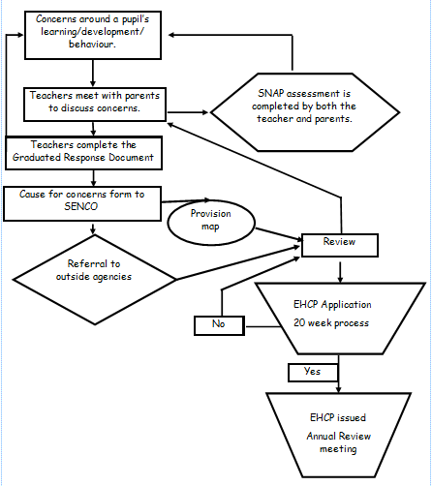This is the process in which our teachers follow:

**How will I be able to raise any concerns I may have?**  
Talk to us- please speak to your child’s class teacher in the first instance. You are also welcome to contact the SENCo, Nurture Room leader or Head teacher as appropriate. We pride ourselves on building positive relationships with parents. We are open and honest with parents and hope that they are able to be the same with us.

**How will the school support my child with SEND**?

Quality first teaching strategies are first and foremost used in all lessons.

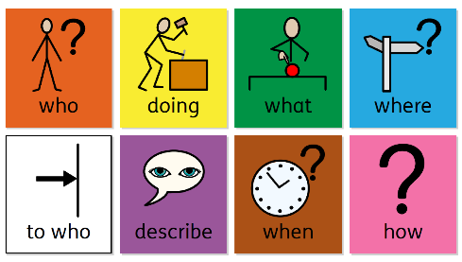*Interventions and support for children with communication and interaction difficulties:*

* Colourful semantics
* Word aware interventions
* Speech and language interventions
* Rainbow interventions
* Wellcomm interventions
* Referrals to SASS (Swindon Autism Support Service)
* Referrals to SALT (Speech and Language Therapist)

Useful links:

Swindon’s SALT services: <https://www.swindon.gov.uk/info/20223/speech_and_language_therapy>

Whole School SEND information on Communication and Interaction: <https://www.wholeschoolsend.org.uk/page/communication-and-interaction>

*Interventions and support for children with cognition and learning difficulties:*

* Precision teaching
* 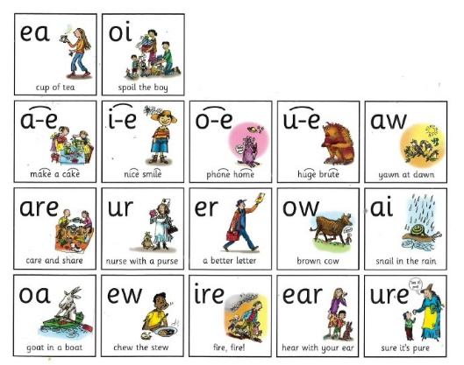Read, Write, Inc Phonics interventions
* Fresh Start interventions
* Accelerated learning groups
* Bucket Time
* Colourful Semantics
* Tiger’s maths groups
* Scoop groups

Useful links:

Whole School SEND information on Cognition and Learning: <https://www.wholeschoolsend.org.uk/page/cognition-and-learning>

*Interventions and support for children with Social, Emotional and Mental Health Difficulties:*

* Rainbow Nurture room
* 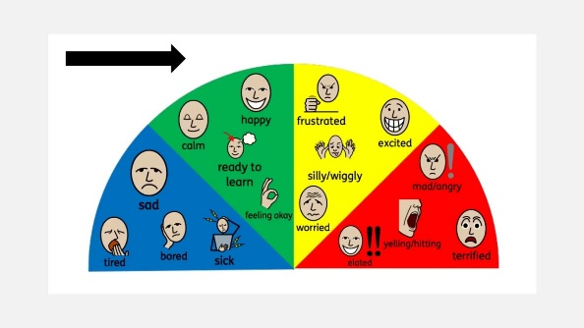Lunch time club
* De-escalation plans
* Play Therapy
* Zones of Regulation
* Family Support Worker
* BeU Swindon
* STEP
* Referrals to Lighthouse

Useful Links:

Whole School SEND information on SEMH: <https://www.wholeschoolsend.org.uk/page/social-emotional-and-mental-health>

[Anna Freud](https://www.annafreud.org/) is a world-leading mental health charity

[NHS Every Mind Matters Wellbeing Tips](https://www.nhs.uk/every-mind-matters/mental-wellbeing-tips/your-mind-plan-quiz/?WT.tsrc=Search&WT.mc_id=Brand&gclid=Cj0KCQiAys2MBhDOARIsAFf1D1c5LMJFxrnwAk2-_9QRZik_5Hrg0W9Q5DWhtNKB2HKES0fWJI7oK3QaAh2kEALw_wcB&gclsrc=aw.ds)

[BeU](https://beuswindon.co.uk/mental-health-advice-and-workshops-for-parents/) – Advice for Parents

[Short films from the NHS](https://www.youtube.com/channel/UCl_TDbv_ZHo6AeQaPokmhYg) Series of short films about healthy family communication and how to support young people who are struggling with their wellbeing and mental health

[Mind](https://www.mind.org.uk/) – Mental Health Charity

[Action for Happiness](https://actionforhappiness.org/sites/default/files/Dec%202023.pdf)

[Swindon Healthy Schools](https://www.swindonhealthyschools.org/)

[Swindon Mental Wellbeing](https://www.swindon.gov.uk/info/20024/health_and_wellbeing/214/mental_wellbeing/2) Support Page

[Lift Psychology](https://www.awp.nhs.uk/our-services/talking-therapies/talking-therapies-swindon) – a resource that provides self-help resources as well as online counselling and therapy sessions

*Interventions and support for children with Physical and/or Sensory Difficulties:*

* SPARKS intervention
* Fine motor interventions
* Braille lessons
* Laptop support
* Sensory Room

 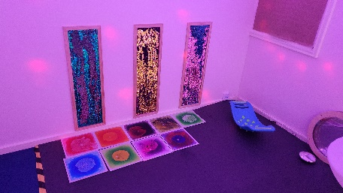

Useful links:

Whole School SEND information on Cognition and Learning: <https://www.wholeschoolsend.org.uk/page/sensory-and-physical>

**What’s Next?**

**How will I know how my child is doing and how will you help me to support my child’s learning?**You are welcome at any time to make an appointment with your child’s class teacher, who can offer advice and practical ways that you can help your child at home. The school offers parents formal parent meetings, to report on pupil progress to date and the next steps in their learning. At these meetings parents are encouraged to share their views and the school may suggest ways in which they can support their child’s learning. Written reports will be shared at these meetings twice a year. Additional meetings can be arranged as necessary. A home/school book or reading log may also be used. If your child has an Education Health and Care Plan (EHCP), then a formal Annual Review meeting will take place at least once per year and you will be able to track their progress and support through the parent Provision Map app. If your child is on the SEND register and has an education plan in place, then you will be able to track their progress and support through the same app.

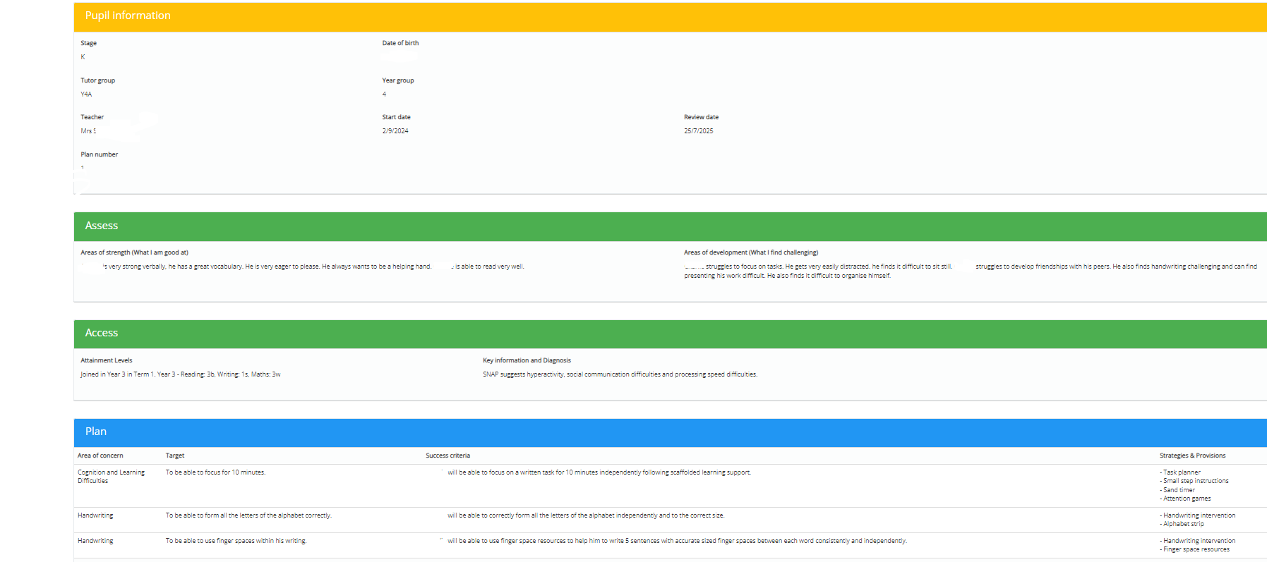

**What support will there be for my child’s overall wellbeing?**  
We are an inclusive school; we welcome and celebrate diversity. All school staff strive to ensure that every child feels safe, happy and valued. All members of staff follow the school’s behaviour policy, and parents are informed of incidents and support given as necessary. Parents and pupils’ views are valued. Staff liaise with external agencies such as social workers or parent support advisers as necessary.  
  
The school has an award-winning nurture room, called the Rainbow room, which has 3 members of staff. They work with pupils individually or in small groups to support emotional, social or behavioural issues.

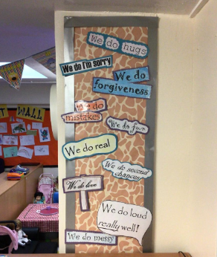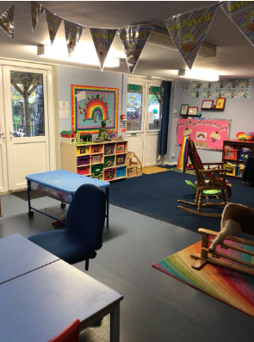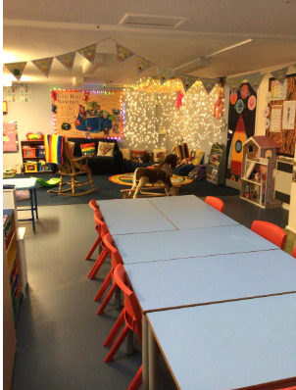   
  
Good attendance is encouraged through an incentive scheme. Attendance is regularly monitored and absences are followed up by school staff. Educational welfare officers give support on matters of attendance, if necessary.  
  
Medical needs are discussed with the School Nurse if appropriate, and an individual health care plan may be drawn up in full consultation with parents.  
  
**How will my child be included in activities outside the classroom including school trips?**  
All pupils are included in aspects of school life as appropriate. The school makes reasonable adjustments to ensure that activities are accessible. A risk assessment is carried out prior to any trips/visitors. In the unlikely event that it is considered unsafe for a child to take part in an activity, then alternative activities will be provided in school.  
  
**How accessible is the setting / school?**  
The ground level of the building is accessible to wheelchairs. Disabled toilet facilities are available. School asks parents if they require help with understanding English and aim to make arrangements to support them if required. (e.g., interpreters, translation)  
**How is the decision made about what type and how much support my child will receive?**  
School regularly assesses pupils and reviews their progress, and therefore identifies those at risk of underachievement. As part of a graduated response, teachers may then differentiate the tasks as necessary. If a pupil requires further support, such as short-term interventions with a particular focus, this will be discussed by the class teacher, the SENCo and relevant members of the SLT. Interventions are then put in place and the impact of this is measured and reviewed. If there is limited progress further interventions may be offered and advice may be sought from other professionals. At each stage of this process, parents and pupils are consulted.  
  
**Who can I contact for further information?**

Please contact the school office to discuss joining our school. If your child has special educational needs a meeting may be arranged with the SENCo. If your child has a EHCP you must first contact Swindon Borough’s Special Educational Needs Assessment Team (Tel. 01793 463062) to discuss any change of placement.

If you would like further information on what Swindon Local Authority offer, please go to the Swindon Local Offer:

<https://www.swindon.gov.uk/sendlocaloffer>

**Other helpful websites**

[https://swindonsendfamiliesvoice.org.uk](https://swindonsendfamiliesvoice.org.uk/) – Swindon Send Family Voices

<https://www.swindon.gov.uk/info/20220/send_newsletters/1565/send_news_splash> **- SEND News Splash**

<https://www.ipsea.org.uk/model-letters> - IPSEA’s model letter page has lots of templates for use

<https://www.swindoncarers.org.uk/> – as a parent of a child with SEND, you may be eligible to register as a parent carer

[https://cerebra.org.uk/](https://cerebra.org.uk/h) - Cerebra UK has lots of advice and support to help wording your DLA application

<https://www.gov.uk/apply-blue-badge>

[https://www.accesscard.online/](https://www.accesscard.online/A)- Access Cards communicate your child’s access requirements to events and venues

[https://www.ceacard.co.uk/](https://www.ceacard.co.uk/C)- CEA cards allow a complimentary ticket for a carer to go to the cinema with a disabled guest

<https://www.swindon.gov.uk/info/20204/leisure_and_activities/1445/short_breaks> - may be able to offer support if you child is unable to access any clubs or groups without support

<https://www.swindoncarers.org.uk/young-carers-support-in-swindon/> - if any siblings are acting as carers, they may be able to access respite and support from peers in a similar situation through Young Carers

<https://www.gov.uk/disabled-facilities-grants> - If you need to make adaptations to your house due to your child’s disability, you may be able to apply for a grant through the Disabled Facilities Grants

<https://www.gov.uk/apply-council-tax-reduction> - If adaptations have to take place in the house, you may be able to request a reduction in council tax

This policy will be reviewed in the 2025/26 academic year.

Agreed by Governing Body…………………………………………………….Date………………………..