Science progression spiral: Working Scientifically, planning

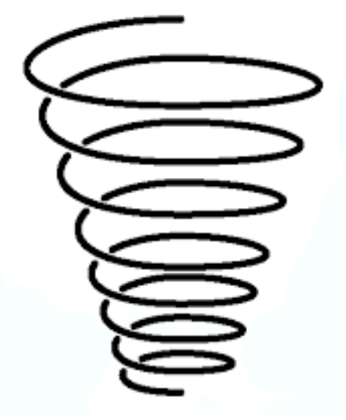

EYFS:

Ask questions about the world around them.

KS1:

Ask simple questions and recognise that they can be answered in different ways

LKS2:

Ask relevant questions and use different types of scientific enquiries to answer them

Set up simple practical enquiries, comparative and fair tests

UKS2:

Plan different types of scientific enquiries to answer questions, including recognising and controlling variables where necessary