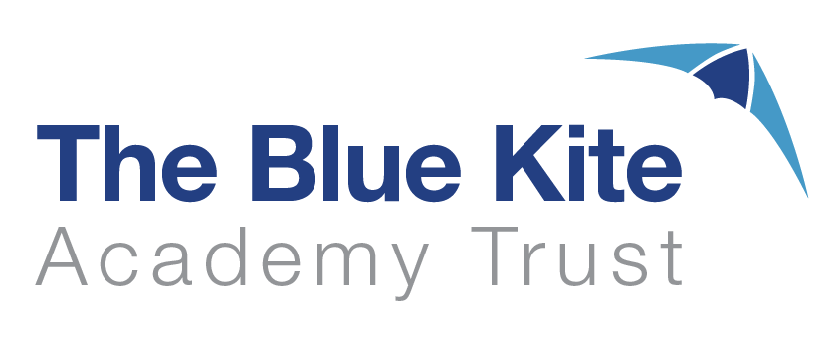

Blue Kite Trust
Assessment Policy

Approved Date: |  | June 2021
Reviewed |  | March 2022  September 2023
Review Date |  | September 2024
Contents Page

- Aims – page 3

2.0 Legislation and Guidance – page 3

3.0 Principles of Assessment – page 3

4.0 Assessment Approaches – page 3

5.0 Collecting and using Data – page 5

6.0 Target Tracker Agreed Bands – pages 6 & 7

7.0 Dates and data deadlines for Target Tracker – page 8

8.0 Moderation & Moderation Record Sheets – pages 9 & 10
AIMS
Provide clear guidelines on the approach to summative assessment and reporting for schools within the Blue Kite Multi-Academy Trust (MAT).
Establish a consistent and coherent approach to recording summative assessment outcomes and reporting to the Trust.

LEGISLATION AND GUIDANCE
Since the removal of National Curriculum levels in 2014, schools have been free to develop their own approaches to assessment.
This policy refers to the recommendations in the Final Report of the Commission on Assessment without Levels.
It also refers to statutory reporting requirements set out in the Education (Pupil Information) (England) Regulations 2005: schedule 1.

PRINCIPLES OF ASSESSMENT
This policy supports the Trust’s ethos of ‘Autonomy – Standardisation – Alignment’ by establishing a core set of assessments to be reported to the CEO and Strategic Education Board twice per year, whilst allowing flexibility in how schools come to these assessments.

This policy is for the recording and reporting of summative assessments and measuring pupil progress.

- Formative Assessment practices are carried out entirely in line with the individual policy of each school. In utilising a common approach to recording assessments, the Trust is mindful of its commitment to not add unnecessarily to teacher workload.
- Summative assessment is to describe pupil attainment and comparatively evaluate the performance of individual pupils and pupil attribute groups both within individual schools and across the trust. Such evaluations will be used to allocate resources and, where beneficial, support to weaker cohorts.
- Progress: Using Target Tracker we will generally measure progress by comparing current attainment with other key starting points: previous year or end of key stage results. We will not use the 6-step system or measure incremental points within a year.

Assessments will be robust and thorough and allow the identification of pivotal pupils within schools to ensure no pupil is coasting in their learning journey. This will be ensured through a range of summative assessments, supported by in-school and inter-school agreement trialling, to ensure the robustness and accuracy of assessment judgements. As a Trust, we will be aspirational for all of our children. It will also identify any pupils who are not accessing their year group’s curriculum.

ASSESSMENT APPROACHES
Blue Kite Trust views assessment as an integral part of teaching and learning, inextricably linked to our curriculum.
We use three broad overarching forms of assessment: day-to-day in-school formative assessment, in-school summative assessment and nationally standardised summative assessment.
Blue Kite schools support the cogent principles that any assessment data produced must serve a purpose and impact on pupils’ learning, and that data should be collected once and used in multiple ways to avoid unnecessary workload for staff.

In-school formative assessment

Effective in-school formative assessment enables:
Teachers to identify how pupils are performing on a continuing basis and to use this information to provide appropriate support or extension, evaluate teaching and plan future lessons
Pupils to measure their knowledge and understanding against learning objectives, and identify areas in which they need to improve

In-school summative assessment

Effective in-school summative assessment enables:
- School leaders to monitor the performance of pupil cohorts, identify where interventions may be required, and work with teachers to ensure pupils are supported to achieve sufficient progress and attainment
- Teachers to evaluate learning at the end of a unit or period and the impact of their own teaching
- Parents to stay informed about the achievement, progress and wider outcomes of their child across a period

Assessments will take two interlinked forms:

Teacher assessment will utilise internal assessment processes, which will vary between schools, to judge where a pupil is attaining in their classwork in relation to what might be expected of a pupil at that point in their school journey.

Standardised testing will use commercially produced and nationally standardised tests in reading and maths in order to compare the attainment of our pupils with those nationally as well as to promote alignment of teacher judgements across and within the different schools of the trust.
It is imperative that standardised tests are delivered in a standardised manner, and as such schools must ensure that test conditions as described in the teachers’ guide supplied by the commercial provider of tests is adhered to.

Schools may use the results of either of these assessments to identify and tackle gaps in pupil learning, and consider how each pupil’s learning interacts with their classroom performance. Schools will use a wide range of evidence including test results supplemented with our day-to-day formative assessment, to inform a robust and evidence informed TA judgement.

Nationally standardised summative assessment
Nationally standardised summative assessment enables:

School leaders to monitor the performance of pupil cohorts, identify where interventions may be required, and work with teachers to ensure pupils are supported to achieve sufficient progress and attainment

Teachers to understand national expectations and assess their own performance in the broader national context

Pupils and parents to understand how pupils are performing in comparison to pupils nationally
Nationally standardised summative assessments include:
- Reception baseline assessment
- Early Years Foundation Stage (EYFS) profile at the end of reception
- Phonics screening check in Year 1
- Year 4 multiplication check
- National Curriculum tests and teacher assessments at the end of Key Stage 1 (Year 2) and Key Stage 2 (Year 6)

COLLECTING, USING AND INTERPRETING DATA
Schools will enter assessments onto Target tracker at the end of each of Term 2 and Term 6.
Teachers will use the exemplification materials developed by the Trust to support their shared understanding of the quality of writing which represents ARE and GDS.

Standardised tests allow us to draw conclusions about how our pupils are performing in relation to their peers nationally, and to compare different cohorts of pupils. Care must be taken when drawing conclusions however on the individual level they can suggest unreliable conclusions since pupils may over or under perform on the test. Where a pupil’s test score and teacher assessed attainment level are not in line, this discrepancy should form the basis of a discussion to examine the reasons for this. When looking at the performance of groups of pupils, care should be taken to avoid over interpreting instances where trends or conclusions are based on small groups. In such instances, disparity between the performance of the pupil attribute group and the general cohort may better prompt discussion than describe firm conclusions about the performance of a school.

Woking above age related expectations (GDS): The pupil applies their learning to different contexts, including other areas of the curriculum. They are able to reason using their knowledge, explain what they are doing and why, and teach others what they have learned.
Working at age-related expectations (ARE): The pupil is working within the curriculum relevant for their year group. The pupil generally achieves their age appropriate curriculum without support in addition to that afforded to all pupils.
Below: The pupil is generally working below the curriculum relevant for their year group. They generally require support in accessing those objectives.
Working significantly below: The pupil is generally working significantly below the curriculum and age-related expectations relevant for their year group. They often require specific support to access the required learning.

Pupils working below their year group curriculum
Where pupils are assessed as Below or Significantly Below, these pupils should be placed on the SEND Register as they must, by definition, have “a significantly greater difficulty in learning than the majority of others of the same age”. Schools must therefore “use their best endeavours to make sure that a child with SEND gets the support they need.” Whilst a pupil assessed as Below will be recorded as such on the data systems that form each school’s summative assessment system, schools will be expected to have additional information on such pupils so that they can identify broadly which year group curriculum the pupil is accessing. In this way such pupils are assessed in line with other pupils, with a focus on what general level the pupil has achieved as opposed to what they cannot yet access.
For pupils operating below Key Stage 1 but engaged in subject-specific learning, schools must record the pupil’s level of attainment using standards 1-4 as defined in the Department for
Education document https://www.gov.uk/government/publications/pre-key-stage-1-standards.

TARGET TRACKER DATA ENTRY

The codes below allow the Trust to consistently gather data from all schools in relation to teacher assessments which are manually entered by teachers to reflect the standards understood to be:
Working Towards, Working At or …Greater Depth with regard to Age Related Expectations in each age group.
Any child working below the Working Towards Standard should be assigned a grade in consultation with the SENDCo.
Within Target Tracker these have different labels and care is needed not to confuse the two.
Target Tracker uses Working Below (for Working Towards), At Risk and Working At (for Working At) and Working Above (for GDS).

National Curriculum Tracking

 |  | Working at Age Related Expectations
National Curriculum (ARE) | Working Towards | Working At  but at risk of falling behind | Working At  Secure | Working At  Potential for GDS | GDS
On Target Tracker | Working Below | Working At  but at risk | Working At | Above | Working Sig. Above
Year 1
Autumn 2 | Rec s | Rec s+ | 1b | 1b+ | 1w
Spring 2 | 1b | 1b+ | 1w | 1w+ | 1s
Summer 2 | 1w | 1w+ | 1s | 1s+ | 2b
Year 2
Autumn 2 | 1s | 1s+ | 2b | 2b+ | 2w
Spring 2 | 2b | 2b+ | 2w | 2w+ | 2s
Summer 2 | 2w | 2w+ | 2s | 2s+ | 3b
Year 3
Autumn 2 | 2s | 2s+ | 3b | 3b+ | 3w
Spring 2 | 3b | 3b+ | 3w | 3w+ | 3s
Summer 2 | 3w | 3w+ | 3s | 3s+ | 4b
Year 4
Autumn 2 | 3s | 3s+ | 4b | 4b+ | 4w
Spring 2 | 4b | 4b+ | 4w | 4w+ | 4s
Summer 2 | 4w | 4w+ | 4s | 4s+ | 5b
Year 5
Autumn 2 | 4s | 4s+ | 5b | 5b+ | 5w
Spring 2 | 5b | 5b+ | 5w | 5w+ | 5s
Summer 2 | 5w | 5w+ | 5s | 5s+ | 6b
Year 6
Autumn 2 | 5s | 5s+ | 6b | 6b+ | 6w
Spring 2 | 6b | 6b+ | 6w | 6w+ | 6s
Summer 2 | 6w | 6w+ | 6s | 6s+ | 7b

To track these across School and/or Trust:
USE
Age Related Expectation Summary Report
AND
Tick the Cumulative & Combined option
BUT
DO NOT TICK the Merge risk and At columns option

EYFS assessment

The way in which formative, developmental assessments within the Early Years Framework are made is devolved to individual schools. The Target Tracker system has capacity for tracking and recording development stages within each strand, and schools may wish to use this.
At the end of each term, schools will record on Target Tracker their summative assessments against each of the strands and against the Early Learning Goals (ELGs) in the summer term.
The Trust will collect summative assessments in the areas of learning which relate to reading, writing, number and shapes, space and measures.

EYFS Tracking
Target Tracker Terms linked to the Revised Development Matters
- Target Tracker Pre3 is referred to within Revised Development Matters as Birth to 3
- Target Tracker Nur is referred to within the Revised Development Matters as 3 and 4 year olds
- Target Tracker Rec is referred to with the Revised Development Matters as Reception

EYFS Profile | Emerging  (Not yet Meeting Expected) | Expected  (At risk of falling behind) | Expected  (Secure within Expected) | Expected  (Potential for More Able) | Expected  (Identified as More Able)
On Target Tracker | Working Below | Working At | Working At | Above? tbc | Working Sig. Above
Nursery
Autumn 2 | Pre3 s | Pre3 s+ | Nur b | Nur b+ | Nur w
Spring 2 | Nur b | Nur b+ | Nur w | Nur w+ | Nur s
Summer 2 | Nur w | Nur w+ | Nur s | Nur s+ | Rec b
EYFS Profile | Emerging  (Not yet Meeting Expected) | Expected  (At risk of falling behind) | Expected  (Secure within Expected) | Expected | Expected  (Identified More Able)
On Target Tracker | Working Below | Working At but at risk | Working At | Above tbc? | Working Sig. Above
Reception
Autumn 2 | Nur s | Nur s+ | Rec b | Rec b+ | Rec w
Spring 2 | Rec b | Rec b+ | Rec w | Rec w+ | Rec s
Summer 2 | Rec w | Rec w+ | Rec s | Rec s+ | 1b

Dates

Annually schools are expected to submit data in the last week of Term 2 (December) and the first full week of July. The Trust will collect this data from the Friday of these respective weeks.
Schools remain free to gather data at a third point in the year (usually Easter) referred to on the charts above as Spring 2. This data is not collected by The Trust but the correct codes should continue to be used as per these charts.

The diagram below shows how Trust-wide assessment and monitoring practices should, wherever possible, be a natural extension of regular school practice and not a separate system.

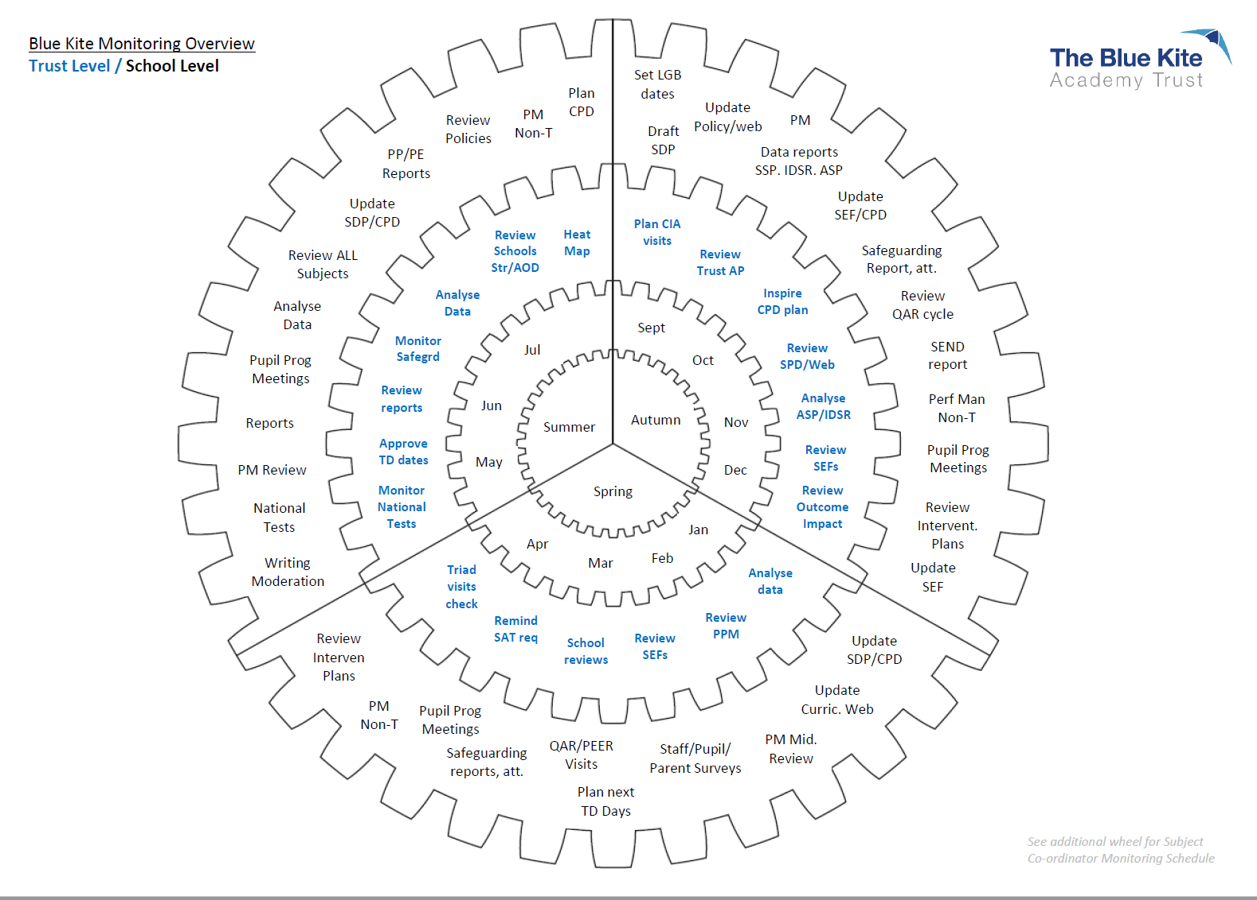

FS2 – Pen Picture...ARE Writing
Brief overview of Pre-School …

Communication & Language | Personal, Social & Emotional
Physical Development | Literacy
Expressive Arts and Design | Understanding the World

Next steps

National Curriculum Years 1-6 Writing Moderation Template
Sections in yellow to be completed by class teacher (1 sheet per child) and brought with child’s books to moderation.
Sections in blue to be completed by 2 teachers from other schools in consultation with class teacher.
Sections in green need to followed up by SLT in relevant school

School being moderated:

Schools who completed moderation:

Child’s  initials |  |  | School judgement for end of year teacher assessment |  | Moderated teacher assessment judgement
Reasons for teacher assessment?
Class teacher to complete before moderation session and bring with child’s book ready to discuss:
Teachers should provide evidence why standard has been met. Where national end of KS standards are available, teachers should refer to these.

Please complete one of the following depending on moderated judgement:
Moderating school to complete:
Reasons why teacher assessment judgement is validated?
To secure teacher assessment judgement, evidence of the following skills is needed:

If further evidence was required, this has been validated by the HT/SLT of individual schools.
Evidence required |  | Checked and validated by |  | Date of internal validation
Copies to: | Head teacher of own school

