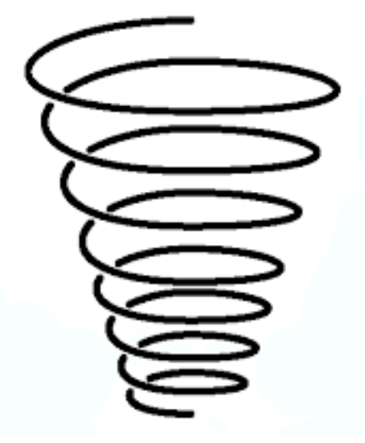

LKS2:

Use timelines to order and discuss events with dates

Use terms related to chronology and the time periods studied

Sequence events, artefacts and historical figures

Make links and find similarities between time periods studied

KS1:

Identify events and people from the past, in order, prior to their life

Begin to know about and understand different periods of time

Begin to understand why certain events happened at certain times

Use timelines to order and discuss events

Use vocabulary associated with time and the passing of time

UKS2:

Ordering key events within a period on a timeline

Use a timeline to order prehistorical events with dates

Can make comparisons between different periods in history that have been studied

Use more complex chronological terminology

EYFS:

Retelling a simple past event in the correct order

Using vocabulary of time

Talking about events that have happened to them – beginning to make sense of themselves and their families’ history