Friday 10th June 2022

Dear Parents and Carers,

Information about this term’s Personal, Social, Health Education: Changing Me

At Oaktree Nursery and Primary School, we use Jigsaw, the mindful approach to PSHE, as our scheme of work to teach PSHE (Personal, Social, Health Education). The programme consists of 6 half-term units, each with 6 lessons. We call these Jigsaw ‘Puzzles’. (Being Me in My World, Celebrating Difference, Dreams and Goals, Healthy Me, Relationships and Changing Me).

In the first half of the Summer Term, we taught the Relationships Topic. Relationships Education is statutory (DfE Guidance 2019) and parents cannot withdraw their children from it. We develop positive relationships throughout the school year and through each Jigsaw Puzzle, but there is a more specific focus on this in this Unit of Work, with children learning about different relationships they have with their friends, family and communities (including staying safe online), and how these relationships change as they grow.

In the second half of the Summer Term, we will be teaching the ‘Changing Me’ Puzzle. This helps children learn to cope positively with all sorts of change. In Key Stage 1 (years 1 and 2), we introduce scientific terminology for body parts, including genitalia, partly for safeguarding reasons and partly to lay the foundations for learning about puberty later in the school.

The purpose of this letter is to inform you of the statutory requirements placed on schools, and what we plan to teach in this topic in PSHE this term.

Health, Relationship and Sex Education

Health and Relationship Education is statutory (required) in all primary schools, and it is recommended that all primary schools have a Sex Education programme that is tailored to the age of the pupils. The Health and Relationship curriculum content is woven throughout the entire programme of Jigsaw, with a specific focus with the ‘Healthy Me’ and ‘Relationships’ Puzzles.

In the Early Years and Key Stage 1, the focus is on life cycles, valuing our own bodies and learning some vocabulary for the external body parts, that we might use if we needed to talk to an adult such as a nurse or a doctor.

In Key Stage 2, there is a particular focus on the Health Education element of puberty in (including menstruation) and the changes that happen inside and outside the body. This is taught in a way that helps pupils feel prepared for the main changes that happen before puberty starts, and to encourage them to talk to an adult at home or at school if they have any questions.

At Oaktree, we define ‘Sex Education’ as a lifelong learning process of acquiring information, developing skills and forming positive beliefs and attitudes about sex, sexuality, relationships and feelings. Sex Education is part of our PSHE/RSE curriculum, and we teach it through the Jigsaw ‘Changing Me’ topic. Please note that animal reproduction is a statutory element of the Year 5 Science curriculum and at Oaktree, we deliver this including human reproduction in Term 6 (this term).

At Oaktree Nursery and Primary School, puberty is taught as a statutory requirement of Health Education and covered by our Jigsaw PSHE Programme in the ‘Changing Me’ Puzzle (unit), and we conclude from the DFE Guidance that sex education refers to Human Reproduction. In order to teach this in a scientific context and knowing that National Curriculum Science requires children to know how mammals reproduce, we have opted to teach this within our Science curriculum, not within PSHE or Relationships and Sex Education as we believe this is most appropriate for our children.

Therefore, your right to withdraw your child is not applicable. We are of course happy to discuss the content of the curriculum and invite you to contact Miss Ballmann – PSHE coordinator (nballmann@oaktree.swindon.sch.uk).

The Jigsaw unit ‘Changing Me’ is taught in the Summer Term and contains 6 pieces (lessons). Each year group will be taught appropriate to their age and developmental stage. We will not teach beyond the remit of the year group. If questions are asked that the staff member feels are inappropriate or are beyond the content for that year group, they may ask the child to ask their parent/carer, or they may acknowledge the question and explain that we will learn about that aspect at another time.

The table below only covers the lessons (pieces) that relate to life cycles, the human body, puberty and human reproduction.
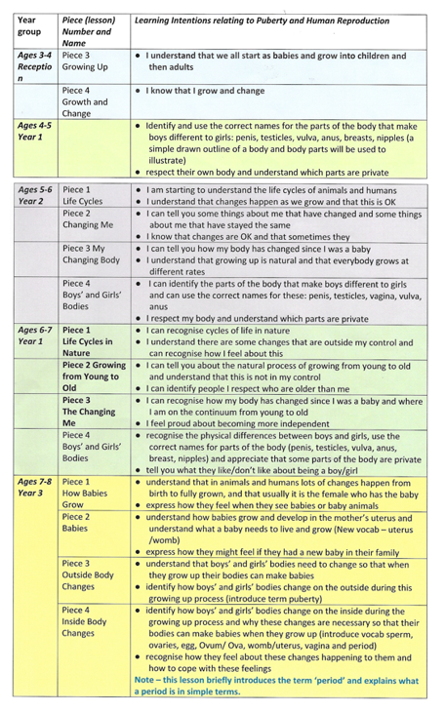

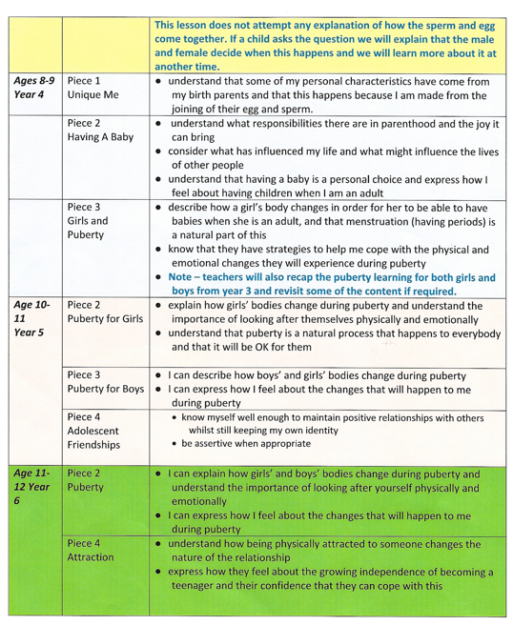
Ware eager to work in partnership with parents.

Please be aware that your child may ask you questions on what they have learnt. There is the Usborne series of growing up books (https://usborne.com/gb/books/series/growing-up) that you might find useful.

We hope that the information we have provided is useful in understanding what your child will be learning this term.

Please refer to our PSHE and RSE policy for further information.

If you have any further questions, please contact your child’s teacher or me via the office.

Kind Regards

Mrs Rees (Head teacher) and Miss Ballmann (PSHE coordinator)

