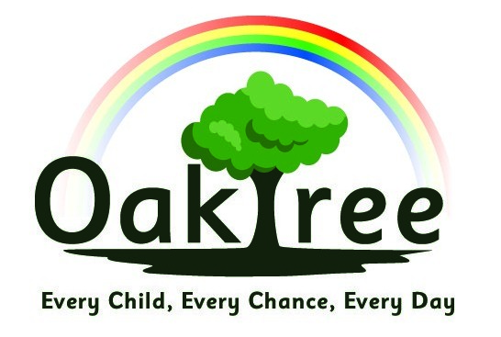

Oaktree Nursery and Primary School

Science Policy

Curriculum Intent

For children to:
- Have a sense of excitement and curiosity about the world around them
- Have a secure knowledge of the different aspects of science taught and have the skills to investigate
- Ask questions and make suggestions about new and existing ideas
- Communicate clearly and coherently their discoveries in a variety of different ways
- Understand the impact of science on our lives and the world we live in and have an understanding of how they can contribute to the world’s future (negative and positive)

Policy into Practice:

- Science is taught in line with our Curious City scheme of work.
- Whenever possible, Science is linked to practical experiences and is enquiry based.
- Teachers use a variety of teaching methods, including modelling, demonstration, use of internet links and videos, experiments (both immediate and over time), research, discussion and debate.
- Topics are revisited but expanded and developed as children progress through the school (see Curriculum Overview).
- Cross curricular links are made through our Curious City scheme of work, and incorporate maths and English where applicable.
- Children are encouraged to communicate findings in a variety of ways such as diagrams, posters, concept cartoons, mind maps, talking partners and group scribing.

Equality of Opportunity

We use a variety of approaches and tasks appropriate to differing ability levels. These include:
- mixed ability groups to promote peer teaching.
- specifically targeting and supporting children with learning barriers and/or children who are having difficulty with particular concepts or vocabulary.
- good quality teaching resources to provide hands on experiences.

Assessment

- Work is assessed in line with the Assessment Policy.
- National curriculum objectives are used as a basis for making judgements about children’s standards in Science.

Covid Guidance
- Equipment will be quarantined for 3 days, or sanitized, before being used by a different bubble
- Children will still take part in paired or group work, within their classes and/ or bubbles

Links to other Policies
Refer to: Equal Opportunities Policy, SEN policy, Assessment and Record Keeping, Teaching and Learning

Date agreed: November 2020

Date of review: September 2022

