SOME OF OUR FAVOURITE SONGS AT NURSERY
HELLO SONG
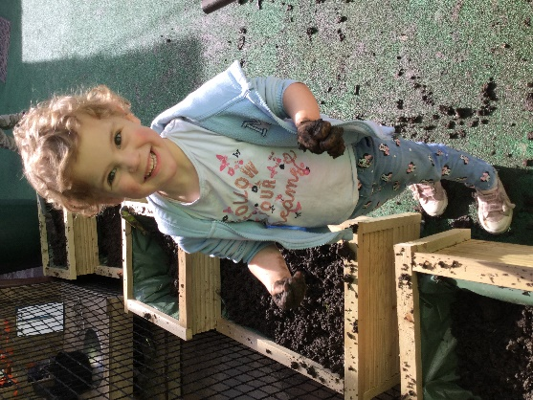
Hello Nursery,
Hello Nursery,
How are you today?
How are you today?
So nice to see you,
So nice to see you,
Come and play,
Every day.

GOODBYE SONG
Goodbye everyone,
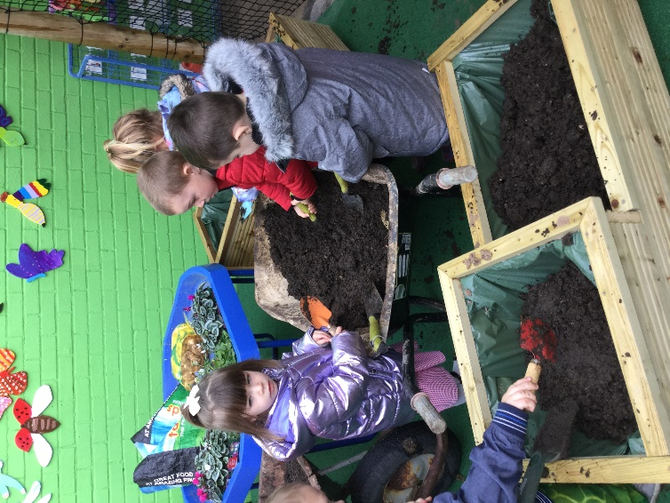
Goodbye everyone,
Goodbye everyone,
We’ll see you all tomorrow,
We hope the sun will shine,
We hope the sun will shine,
We hope the sun will shine,
when we see you tomorrow.

