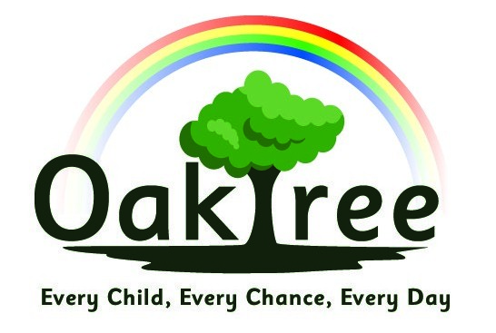
Reading Provision Map for Oaktree March 2022
Year Group | Provision
FOUNDATION STAGE
Acorns | Story time, Story CDs  Singing  Nursery rhymes  Daily Story Reading together  Focused book for the term  Stories shared on Class Dojo of adults reading stories  Library Visits  Vocabulary building through rhymes and games; nursery rhyme words sent home  Early Words Together  WellComm  Stay And Play  Lotto games and Sound Pegs  Books available throughout the setting in all areas  Book baskets  Visual story pictures displayed throughout the setting  Older children to read to younger learners  Hungry Little Minds campaign – Literacy resources and activities are shared with parents.  Weekly stories and visuals in the woodland area  Instruments
Nursery | Focus book of the week / weeks  Daily Story Reading together  Story links on Class Dojo  Fred Games (Action: Janet to look at RWI Nursery and training)  Weekly phonics carpet time  Nursery Rhymes  Singing opportunities  Child-Led Book Talk  Engaging with books through: puppets, story boards, re-enacting  Links made with familiar books in different settings (e.g. the forest) including when child led  Foundation Stage Library visits, books sent home  Stay and Play  WellComm  Book available throughout the setting  Book corner  Wellie walks to the local library  Listening walks  Early Words Together at 3-4  Yoto player – story player  Instruments  Older children to read to younger learners
Reception | RWI Daily Phonics (30 minutes initially, increasing once on story books)  Daily Story Reading together  Flexible intervention groups – Phonics and reading focus  RWI Fast Track 1:1 tutoring  WellComm  6 x yearly RWI Assessments, plus additional assessments if needed (e.g. if new to school)  Hearing individual readers  Child-Led Book Talk  Contingent Talk 1:1  Rhymes and singing  Talk for Writing  Helicopter stories  Book focus to lead learning  Library visits?  RWI Phonic films (specific sounds) shared with Class Dojo for children to access at home  Oxford Owl online e-books available  RWI Book, Matched Book Bag Book and a Sharing Book all to take home weekly  Book baskets around the class  Book corner  Older children to read to younger learners
KEY STAGE ONE
1 | Daily Story Reading together  Talk for Writing  Books linked to Enquiries  Books linked to Literacy  Individual reading to an adult  Additional opportunities to read to an adult for children who do not read regularly at home  Reading Interventions  Reading Assessments: Salford Reading Test, YARC, Benchmarking  Reading Rewards  RWI Phonics daily  RWI Fast Track 1:1 tutoring  RWI Phonic films shared with Class Dojo for children to access at home  6 x yearly RWI Assessments, plus additional assessments if needed (e.g. if new to school)  Oxford Owl online e-books available  RWI Book, Matched Book Bag Book and a Sharing Book all to take home weekly  Book corner  Phonics Screening
2 | Daily Story Reading together  Talk for Writing  Books linked to Enquiries  Guided Reading  Individual reading  Reading Interventions  Reading Assessments: Salford Reading Test, YARC, Benchmarking  Additional opportunities to read to an adult for children who do not read regularly at home  Weekly VIPERS Reading Comprehension lesson  Reading Rewards  RWI Phonics daily  RWI Fast Track 1:1 tutoring  RWI Phonic films shared with Class Dojo for children to access at home  6 x yearly RWI Assessments, plus additional assessments if needed (e.g. if new to school)  Oxford Owl online e-books available  RWI Book, Matched Book Bag Book and a Sharing Book all to take home weekly  Book corner  60 second reads once off RWI  SATs comprehension practice tests  SATs comprehension
LOWER KEY STAGE TWO
3 & 4 | Daily Story Reading together  RWI Groups for those children who have not reached Grey  RWI Fast Track 1:1 tutoring  RWI Phonic films shared with Class Dojo for children on RWI to access at home  6 x yearly RWI Assessments, plus additional assessments if needed (e.g. if new to school)  Oxford Owl online e-books available to those children on RWI  For those children on RWI - RWI Book, Matched Book Bag Book and a Sharing Book all to take home weekly  Reading Assessments: Salford Reading Test, YARC, Benchmarking  Reading Rewards  Book-based English lessons  Books linked to Enquiries  VIPERS Reading for children who are on Yellow, Blue or Grey and above RWI colours  Additional opportunities to read to an adult for children who do not read regularly at home  Book Corner time and reading opportunities  Take Home books (appropriate level)  Book corner  60 second reads once off RWI
UPPER KEY STAGE TWO
5 & 6 | Daily Story Reading together  Fresh Start Phonics  Reading Assessments: Salford Reading Test, YARC, Benchmarking  Reading Rewards  Book-based English lessons  Books linked to Enquiries  VIPERS Reading for children  Additional opportunities to read to an adult for children who do not read regularly at home  Book Corner time and reading opportunities  Take Home books (appropriate level)  Older children to read to younger children  Book corner  Reading their writing aloud to a partner.

