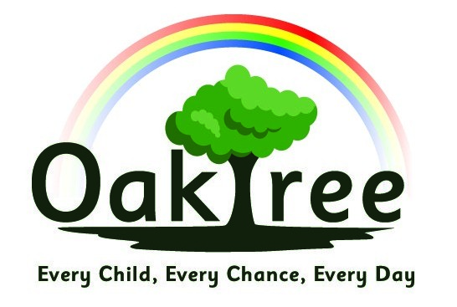

**Oaktree Nursery and Primary School**

**Science Policy**

**Curriculum Intent**

For children to:

* Have a sense of excitement and curiosity about the world around them
* Have a secure knowledge of the different aspects of science taught and have the skills to investigate
* Ask questions and make suggestions about new and existing ideas
* Communicate clearly and coherently their discoveries in a variety of different ways
* Understand the impact of science on our lives and the world we live in and have an understanding of how they can contribute to the world’s future (negative and positive)

**Policy into Practice:**

1. Science is taught following the National Curriculum end of phase expectations.
2. Whenever possible, Science is linked to practical experiences and is enquiry based.
3. Children are explicitly taught about the different types of enquiry and working scientifically skills they practice.
4. Teachers use a variety of teaching methods, including modelling, demonstration, use of internet links and videos, experiments (both immediate and over time), research, discussion and debate.
5. Topics are revisited but expanded and developed as children progress through the school (see Curriculum Overview).
6. Children are encouraged to communicate findings in a variety of ways such as diagrams, posters, concept cartoons, mind maps, talking partners and group scribing.
7. Children are provided with opportunities to review prior learning through quizzes, videos, group or whole class discussion and games.

**Equality of Opportunity**

We use a variety of approaches and tasks appropriate to differing ability levels. These include:

* mixed ability groups to promote peer teaching.
* specifically targeting and supporting children with learning barriers and/or children who are having difficulty with particular concepts or vocabulary.
* good quality teaching resources to provide hands on experiences.
* providing opportunities to record work in a variety of ways

**Assessment**

* Work is assessed in line with the Assessment Policy.
* National curriculum objectives are used as a basis for making judgements about children’s standards in Science.

**Links to other Policies**

Refer to: Equal Opportunities Policy, SEN policy, Assessment and Record Keeping, Teaching and Learning

Date agreed: January 2024

Date of review: January 2026