Music progression spiral: Composition

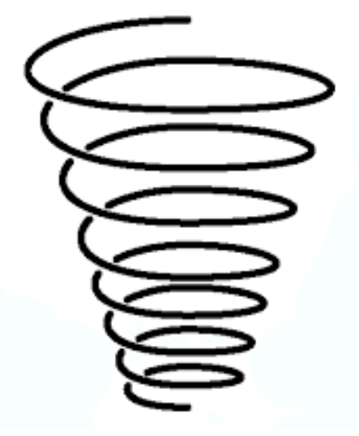

UKS2:

* Create simple melodies using up to five different notes and simple rhythms that work musically with the style of the Unit song.
* Listen to and reflect upon the developing composition and make musical decisions about how the melody connects with the song.
* Record the composition in any way appropriate that recognises the connection between sound and symbol (e.g. graphic/pictorial notation)

LKS2:

* Create a simple melody using one, three or five different notes.
* Plan and create a section of music that can be performed within the song.
* Talk about how it was created.
* Make musical decisions about pulse, rhythm, pitch, dynamics and tempo.
* Record the composition, using pictorial notation

EYFS:

Create patterns of music using percussion (tuned and untuned) instruments

KS1:

* Help create a simple melody with the Units using two or three different notes
* Learn how the notes of the composition can be written down and changed if necessary