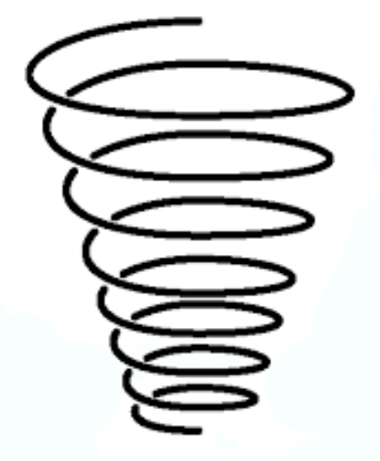

EYFS: To learn and practise step 1 of tricky skills (Real Gym) shape, balance, travel, flight and rotation skills.

KS1: To perform on the floor steps 1, 2 and 3 of tricky skills (Real Gym) shape, balance, travel, flight and rotation skills.  
Begin combining these skills with one of the following:  
hand apparatus;  
low apparatus;  
larger apparatus;  
or with a partner.

UKS2: To perform on the floor steps 1, 2 and 3 of trickiest skills (Real Gym) shape, balance, travel, flight and rotation.   
To combine the trickier skills (learnt in LKS2) with one of the following:  
hand apparatus;  
low apparatus;  
larger apparatus;  
or with a partner.

LKS2: To perform on the floor steps 1, 2 and 3 of trickier skills (Real Gym) shape, balance, travel, flight and rotation.   
To combine the tricky skills (learnt in KS1) with one of the following:  
hand apparatus;  
low apparatus;  
larger apparatus;  
or with a partner.

Exceeding UKS2: To also combine the trickiest skills (learnt in UKS2) with two or more of the following:  
hand apparatus;  
low apparatus;  
larger apparatus;  
or with a partner.