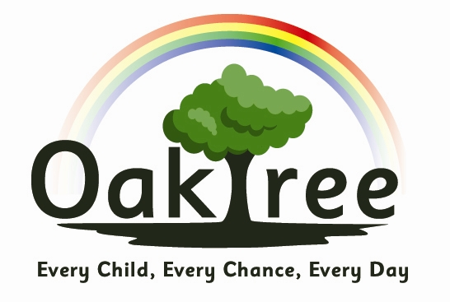

Oaktree Nursery and Primary School

EYFS Nappy Changing & Toileting Policy

Policy Statement:
No child is excluded from participating in our setting who may, for any reason, not yet be toilet trained and who may still be wearing nappies or equivalent. We work with parents and carers towards toilet training, unless there are medical or other developmental reasons why this may not be appropriate at the time. We make necessary adjustments to our bathroom provision and hygiene practice in order to accommodate children who are not yet toilet trained. We see toilet training as a self-care skill that children have the opportunity to learn with the full support and non-judgemental concern of adults.

Procedures:
- Changing areas are warm and there are safe areas to lay young children if they need to have their bottoms cleaned.
- Each young child has their own bag with their own nappies or ‘pull ups’ and wipes.
- Gloves are put on before changing starts and are disposed of after one use.
- Changing mat to be sprayed and wiped before and after each use.
- All staff are familiar with the hygiene procedures and carry these out when changing nappies.
- Staff ensure that nappy changing is relaxed and a time to promote independence in young children.
- They will be encouraged to wash their hands and have soap and towels to hand. They should be allowed time for some play as they explore the water and the soap. Hand washing with soap to last at least 20 seconds.
- Staff are gentle when changing; they avoid pulling faces and making negative comments about ‘nappy contents’.
- Older children access the toilet when they have the need to and are encouraged to be independent.
- Nappies and ‘pull ups’ are disposed of hygienically, bagged and put in the bin. Cloth nappies, trainer pants and ordinary pants that have been wet or soiled are bagged for the parent to take home.
- NB If young children are left in wet or soiled nappies / ‘pull ups’ in the setting this may constitute neglect and will be a disciplinary matter. Settings have a ‘duty of care’ towards children’s personal needs.
- An appropriate level of supervision and assistance will be given to children, whilst encouraging independence when appropriate.
Children will be treated with respect and dignity at all times.

This policy is reviewed annually. It is published on the school website.

Policy Date: September 2022
Review Date: September 2023

