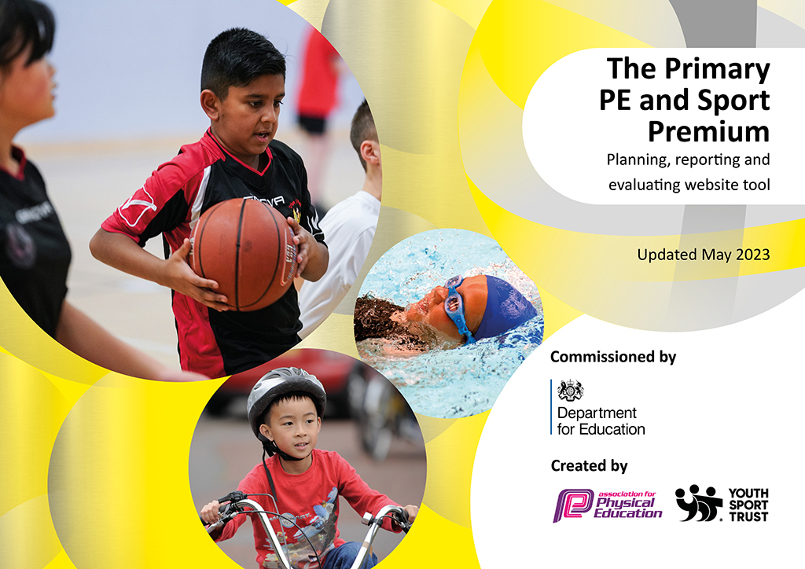
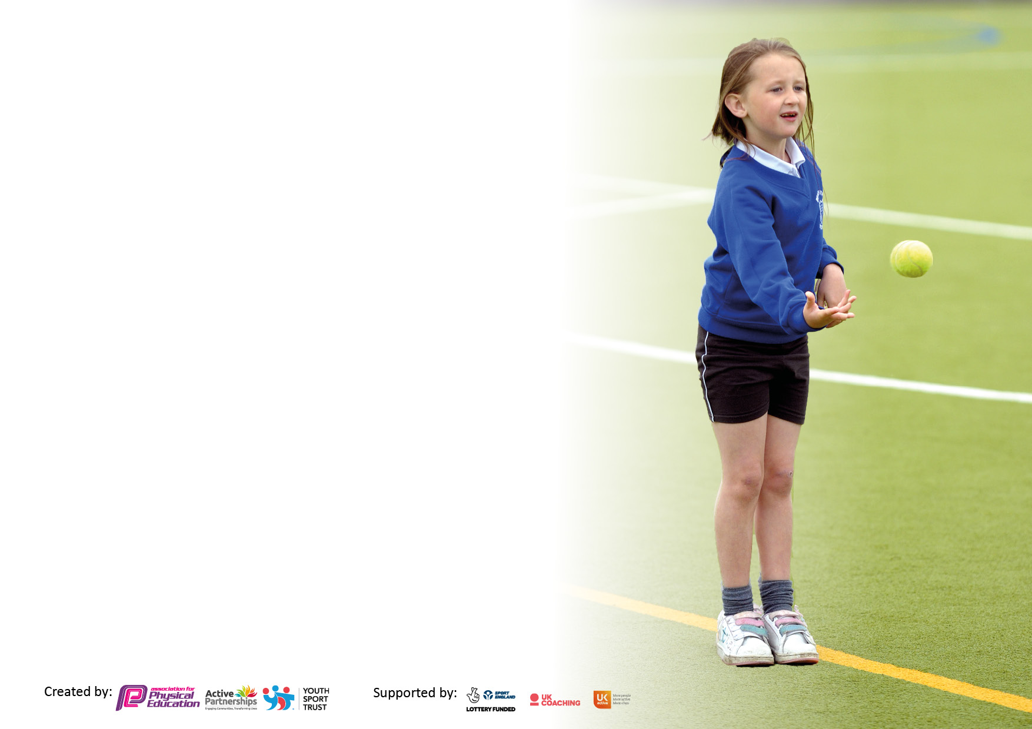

It is important that your grant is used effectively and based on school need. The Education Inspection Framework makes clear there will be a focus on ‘whether leaders and those responsible for governors all understand their respective roles and perform these in a way that enhances the effectiveness of the school’.

Under the Quality of Education Ofsted inspectors consider:
Intent - Curriculum design, coverage and appropriateness
Implementation - Curriculum delivery, Teaching (pedagogy) and Assessment
Impact - Attainment and progress

To assist schools with common transferable language this template has been developed to utilise the same three headings which should make your plans easily transferable between working documents.

Schools must use the funding to make additional and sustainable improvements to the quality of Physical Education, School Sport and Physical Activity (PESSPA) they offer. This means that you should use the Primary PE and sport premium to:

- Develop or add to the PESSPA activities that your school already offer
- Build capacity and capability within the school to ensure that improvements made now will benefit pupils joining the school in future years
- The Primary PE and sport premium should not be used to fund capital spend projects; the school’s budget should fund these.

Pleasevisitgov.ukfortherevisedDfEguidanceincludingthe5keyindicatorsacrosswhichschoolsshoulddemonstrate animprovement.Thisdocumentwillhelpyoutoreviewyourprovisionandtoreportyourspend.DfEencouragesschools to use this template as an effective way of meeting the reporting requirements of the Primary PE and Sport Premium.

We recommend you start by reflecting on the impact of current provision and reviewing the previous spend.

Schools are required to publish details of how they spend this funding, including any under-spend from 2021/2022, as well as on the impact it has on pupils’ PE and sport participation and attainment. All funding must be spent by 31st July 2023.

We recommend regularly updating the table and publishing it on your website throughout the year. This evidences your ongoing self-evaluation of how you are using the funding to secure maximum, sustainable impact. Final copy must be posted on your website by the end of the academic year and no later than the 31st July 2023. To see an example of how to complete the table please click HERE.

Details with regard to funding
Please complete the table below.

Total amount carried over from 2021/22 | £8155
Total amount allocated for 2021/22 | £18965
How much (if any) do you intend to carry over from this total fund into 2022/23? | £8155
Total amount allocated for 2022/23 | £18,820
Total amount of funding for 2023/23. To be spent and reported on by 31st July 2023. | £ 26,975
Swimming Data
Please report on your Swimming Data below.

Meeting national curriculum requirements for swimming and water safety.  N.B. Complete this section to your best ability. For example you might have practised safe self-rescue techniques on dry land which you can then transfer to the pool when school swimming restarts.  Due to exceptional circumstances priority should be given to ensuring that pupils can perform safe self rescue even if they do not fully meet the first two requirements of the NC programme of study | 23%
What percentage of your current Year 6 cohort swim competently, confidently and proficiently over a distance of at least 25 metres?  N.B. Even though your pupils may swim in another year please report on their attainment on leaving primary school at the end of the summer term 2022.  Please see note above | 51%
What percentage of your current Year 6 cohort use a range of strokes effectively [for example, front crawl, backstroke and breaststroke]?  Please see note above | 23%
What percentage of your current Year 6 cohort perform safe self-rescue in different water-based situations? | 23%
Schools can choose to use the Primary PE and sport premium to provide additional provision for swimming but this must be for activity over and above the national curriculum requirements. Have you used it in this way? | Yes/No £1960

Action Plan and Budget Tracking
Capture your intended annual spend against the 5 key indicators. Clarify the success criteria and evidence of impact that you intend to measure to evaluate for pupils today and for the future.

Academic Year: 2022/23 | Total fund allocated: | Date Updated:
Key indicator 1: The engagement of all pupils in regular physical activity – Chief Medical Officers guidelines recommend that primary school pupils undertake at least 30 minutes of physical activity a day in school |  |  |  | Percentage of total allocation:
 |  |  |  | 5%
Intent | Implementation |  | Impact
Your school focus should be clear what you want the pupils to know and be able to do and about  what they need to learn and to  consolidate through practice: | Make sure your actions to achieve are linked to your intentions: | Funding allocated: | Evidence of impact: what do pupils now know and what can they now do? What has changed? | Sustainability and suggested next steps:
To increase physical activity on a daily basis through outside play across the school. | MDSA led playtime sessions in activities e.g. skipping, ball games and games that encourage physical activity.  Play equipment purchased e.g. skipping ropes, balls | £0  £1558 | A higher proportion of children are now engaged in physical activity for longer periods during playtimes. | Real Leaders training for staff to set up Play Leaders to further support active playtimes and engage more children in physical activity.
Key indicator 2: The profile of PESSPA being raised across the school as a tool for whole school improvement |  |  |  | Percentage of total allocation:
 |  |  |  | 13%
Intent | Implementation |  | Impact
Your school focus should be clear what you want the pupils to know and be able to do and about  what they need to learn and to  consolidate through practice: | Make sure your actions to achieve are linked to your intentions: | Funding allocated: | Evidence of impact: what do pupils now know and what can they now do? What has changed? | Sustainability and suggested next steps:
Daily mile to encourage children to be active throughout the day and to improve stamina.  Encourage less-active children to engage in physical activity outside of PE lessons.  Enrich Education cross curricular outdoor learning package | PE Leads monitor Daily Mile to ensure that all children access this provision regularly.  Children participate in Project Me Mentoring Programme ran by Swindon Town Football Club to support mental health through physical activity. Youth Support Trust membership to further support physical activity for disengaged pupils.  Orienteering installation including cross curricular physical activities to encourage physical activity across all year groups.  . | £0  £1225  £2280 | Children’s stamina is increasing and they are able to complete the mile at the end of the year in a shorter amount of time compared to the beginning.  Data collected by STFC at the end of the programme showed significant improvement on children’s fitness levels and ability to participate in physical activity.  Children access outdoor and adventurous activity outside of curriculum PE lessons. | Continue to monitor to ensure children are accessing the Daily Mile regularly.

Key indicator 3: Increased confidence, knowledge and skills of all staff in teaching PE and sport |  |  |  | Percentage of total allocation:
 |  |  |  | 22%
Intent | Implementation |  | Impact
Your school focus should be clear | Make sure your actions to | Funding | Evidence of impact: what do | Sustainability and suggested
what you want the pupils to know | achieve are linked to your | allocated: | pupils now know and what | next steps:
and be able to do and about | intentions: |  | can they now do? What has
what they need to learn and to |  |  | changed?
consolidate through practice:
Create Development Real Legacy membership  Attend PE conference to deepen subject knowledge in order to build confidence and support teaching staff  Staff meeting to discuss delivery and assessment of subject and ensure coverage and progression of PE throughout the school.  Fortius PE Membership – provides opportunities for children to attend local intra-school events as well as increasing staff confidence and skills | Provides online support for delivering PE sessions, staff CPD sessions and in-school support days.  PE Leads to attend conference and feedback to staff.  Staff have a clear understanding of the PE curriculum and the progression across phases. Staff are able to use agreed assessment format to monitor children’s progress.  Provides CPD opportunities, conferences for PE Lead to attend and entry to intra-school events. | £4914  £320  £0  £600 | Staff have been supported through team teach sessions and workshops building confidence when delivering PE sessions.  Developed PE Lead’s subject knowledge and gained awareness of further opportunities to enhance PESSPA across the school.  Staff have used the agreed assessment format which informs current class teachers, new class teachers and PE Leads of the children’s progress and areas of development.  PE Leads attended PE conference and opportunities for children to participate in intraschool events.
Key indicator 4: Broader experience of a range of sports and activities offered to all pupils |  |  |  | Percentage of total allocation:
 |  |  |  | 9%
Intent | Implementation |  | Impact
Your school focus should be clear | Make sure your actions to | Funding | Evidence of impact: what do | Sustainability and suggested
what you want the pupils to know | achieve are linked to your | allocated: | pupils now know and what | next steps:
and be able to do and about | intentions: |  | can they now do? What has
what they need to learn and to |  |  | changed?
consolidate through practice:
Additional achievements:  Bikeability course  Dance workshops from Swindon Dance  Circus skills – Children to experience new activities promoting physical activity including coordination and balance  Trampolining – children to experience new activities promoting physical activity | Year 4 children completed Level 1 of the Bikeability course off road gaining skills needed to complete Level 2.  Year 5 and 6 completed Level 2 of the Bikeability course learning and developing skills covered by the National Standard syllabus.  All year groups participate in 2 dance workshops covering a variety of dance styles e.g. street dance and contemporary.  All children participate in a workshop learning circus skills focusing on developing coordination and balance and then participate in a show to demonstrate their new skills.  Children attended a leisure centre and participated in trampolining. | £0 – delivered by Lifecycle UK in partnership with Swindon Borough Council free of charge.  £682  £1310  £486 | All children who participated achieved Level 1 or 2.  Children participated in the sessions with enthusiasm and were able to explore new experiences.  Children participated in the sessions with enthusiasm and were able to demonstrate their new skills to other year groups within the school.  Children enjoyed participating in physical activity and were physically active for a substantial amount of time.

Key indicator 5: Increased participation in competitive sport |  |  |  | Percentage of total allocation:
 |  |  |  | 3%
Intent | Implementation |  | Impact
Your school focus should be clear | Make sure your actions to | Funding | Evidence of impact: what do | Sustainability and suggested
what you want the pupils to know | achieve are linked to your | allocated: | pupils now know and what | next steps:
and be able to do and about | intentions: |  | can they now do? What has
what they need to learn and to |  |  | changed?
consolidate through practice:
SEN bowling competition  Sports Day Competitions – Children participating and competing against others in different areas of athletics.  Ball skills club | SEN children competed in a tenpin bowling competition against local schools. All participants were awarded a certificate and medal.  Sports Day equipment purchased to broaden the amount of activities children participate in.  Children attended an extra-curricular club with a focus on ball skills enabling them to participate in a variety of competitive sports. | £0  £720  £190 – equipment | Children represented Oaktree in a competition and celebrated their achievements.  All children participated fully in Sports Day. Participation and achievements were celebrated. Feedback from children, staff and parents was positive.  Participation of the club was good and children’s feedback showed that they enjoyed participating in competitive team sports.

Signed off by
Head Teacher: | Kate Howard (acting Head)
Date: | 25.07.23
Subject Leader: | Ellie Wells
Date: | 24.07.23
Governor: | Erica Milsom (Chair of Governors)
Date: | 25.07.23

