Home Learning Bingo Sheet: Week beginning 22.6.20 - OURSELVES
Select an activity of your choice from each column each day. Can you get a line? A full house? By the end of the week.
English | Phonics | Maths | Rainbow challenges
Read, or listen to, the story.  Monkey Puzzle by Julia Donaldson  https://www.youtube.com/watch?v=CIhJ5iAelEQ  How many different animals can you spot in this story? Do any of these animals live around us? Go on a walk and see if you can spot any. | Play snap with this week’s sounds (see bottom of page) | Addition and subtraction workout C (see attached sheet)  Challenge – Draw more of your own part whole diagrams. Can you use a 2 digit number with a 1 digit number? Can you make the whole 100? | Print out a picture of a monkey, or use a toy. Hide it and then see if you can describe to a friend where to find it using words like ‘next to, under, above, below’ | Our skeleton is a part of our body. Watch the video that tells you all about this: https://www.bbc.co.uk/bitesize/clips/zmptsbk  Make a skeleton of your body by cutting and sticking straws on to a piece of paper.
Imagine your Mum was lost. Create a missing poster for your Mum. You will need to draw a picture of her and describe what she looks like. | Play Quickwrite. How many words can you write with this week’s sound in a minute? | Missing number workout E (see attached sheet)  Challenge – Complete this using the digits 0, 1, 2, 3, 4, 5, 6, 7, 8 and 9 only once | In the story little monkey started off feeling worried but by the end he was happy. Try making different faces for different emotions. Complete the worksheet ‘How Do You Feel?’ | Learn and sing the song ‘Head, shoulders, knees and toes’. How quickly can you sing it without making any mistakes with the actions?
Look at the riddles attached. Can you guess the animal? Create your own riddle about yourself or a member of your family. Think carefully about which adjectives to use to help you describe that person accurately. Can anyone guess who your riddle is about? | Go round the house and collect objects that have that sound in them. | Play Odd Tic Tac Toe  This is the same as ‘Noughts and Crosses’ but instead of using o and x use 1 and 0. You are the winner if your line adds up to an odd number. Are there any places on the board that are not good to go in? | Use the ‘Jigsaw’ sheet and draw a picture of a monkey on it to make your own ‘monkey puzzle’. Instead of a monkey you could draw a picture of yourself. Stick the sheet onto some card and then cut along the lines. When all your puzzle pieces have been cut out try to put them back together again to make the picture. | Create a poster that tells us all about you. It could tell us things you like, dislike, how old you are, who your family are, where you live, what your favourite colour or animal is or what you want to be when you grow up (see Purple Mash ‘All about Me’).
Write a list of 5 things that are the same about you and your Mum. Now write a list of 5 things that are different about you and your Mum. | Make a phoneme frame (draw a box with 3,4 or 5 spaces, each space can be filled with a sound in the word) and use it to help you spell out some words with this week’s sounds. | Number round up: https://nrich.maths.org/188/index  (see attached sheet)  Use all the numbers 1 to 6 and place them in the circles. The sum (adding) of each side of the triangle should be the same as the number in the middle. | Talk about parts of your body. Draw around yourself and try to label as many different parts of your body as you can (see Purple Mash ‘My Body’). | Use a mirror to help you paint a self-portrait. Look carefully what colour hair and eyes you have. What shape is your nose and mouth?
This week’s sounds for phonics are: ir, oy, ph, th, oi
Maths Workouts and Problems

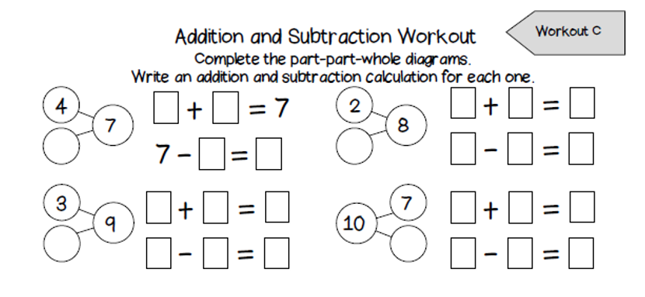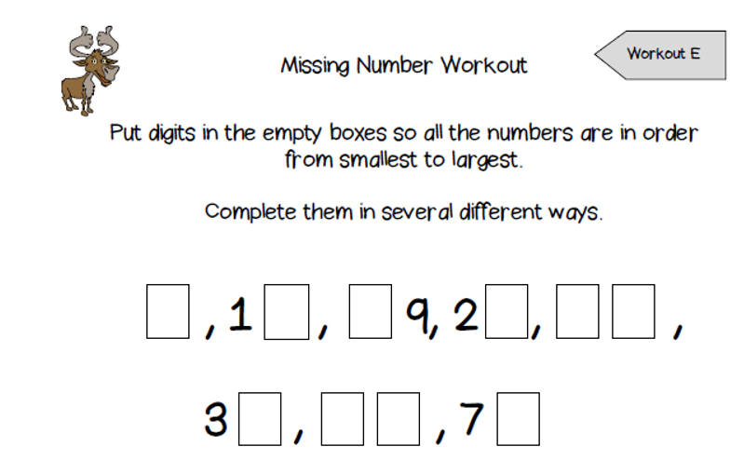

Number Round Up
