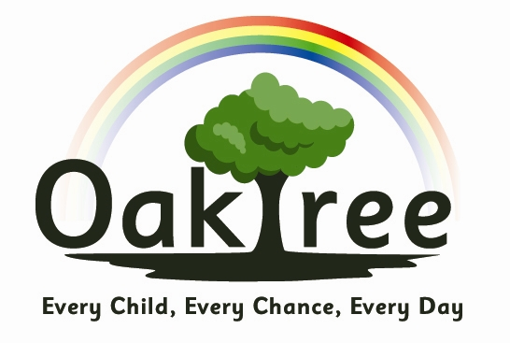

Oaktree Nursery and Primary School

EYFS Records and Data Policy

Induction forms will be kept in a file in the Child’s Class (in Admin cupboards). Forms will be accessible to relevant members of staff only. Contact details will updated as and when needed. Any changes will be passed on to the office. Details from Acorns will be passed onto Nursery and details from Nursery will be passed onto Reception teachers. They will be checked and updated at the induction meetings. Reception teachers will pass on details to Year 1.

If a child leaves the Foundation Stage before the end of FS2 details will be kept for 3 years, then destroyed. Details of children moving up to KS1 will be given to their class teacher.

Child protection concerns are completed online using CPOMS. A safeguarding sheet will be kept on the back of a cupboard door to allow access for staff covering the group. The format for this sheet will be given by the Designated Safeguarding Lead.

Assessments
Observational assessments will be carried out throughout the year. These are sometimes recorded on Focus Child Sheets which are kept together in a file. There is no requirement to record all observations or keep evidence of all learning. It is the process of the learning that is taking place that is important and any records kept need to be useful and informative. Photos of the children and their work will also be stored on ClassDojo, either on the class story or in the child’s individual portfolio. All parents are strongly encouraged to download the free ClassDojo app to have access to this information on their child. If they do not have the app, the class teacher will share the photos and observations with them at parent consultations.

Formal assessment data is stored in a class file and used to inform planning. This data is also shared with parents at parent consultations. This data, along with the observational assessments, will be passed to the next class teacher if relevant.

SEN
Information on a child’s special educational needs will be stored in their class SEN folder or in a child’s individual SEN folder. Information from intervention programmes will be stored in the class. They will be accessible to the SENCO, the class teacher and relevant staff members.

This policy is reviewed annually. It is published on the school website.

Policy Date: September 2022
Review Date: September 2023

