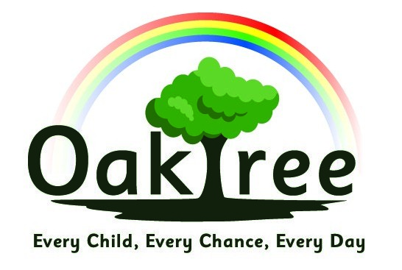

Oaktree Primary and Nursery School

Physical Education Policy
Date agreed: March 2021
Next review due in September 2022

Rationale
At Oaktree Nursery and Primary school, the well-being of the children is at the heart of everything we do. This is supported through Physical Education (PE) by educating the children on the positive impact that physical exercise has on their physical and mental wellbeing. A high-quality PE curriculum inspires all children to excel whilst building on their enjoyment, confidence and skills in physical activity, whilst promoting personal, social, cognitive and creative skills that can be applied across all areas of the curriculum. We aim to equip all children with the skills and knowledge to develop healthy habits for life.

Aims

For children to:

- Enjoy, and have the confidence to participate in, a range of physical activities
- Understand the positive effects that physical activities have on well-being and mental health
- Have the skills which enable them to access a broad range of physical activities and lead healthy, active lifestyles
- Be physically active for sustained periods of time

Areas of Activity
Whilst highlighting the need for children to plan, perform and evaluate their work as part of the PE program, the main emphasis in the National Curriculum is on participation.
The National Curriculum requires that children participate in the following areas of activity:-
In FS and KS1 | In KS2
Dance Activities  Team Games Activities  Movement Skills such as running, jumping, throwing and catching, balancing, agility and co-ordination | Dance Activities  Games Activities  Gymnastics and Athletics Activities  Swimming Activities and Water Safety  Outdoor and Adventurous Activities

Physical Education and SEND
Teaching PE to pupils with SEND is an extension of good practice, via differentiation, something that is incorporated into each unit within the Real Legacy scheme of work. Appropriate differentiation will not only improve their movement skills, but will also help to change feelings of under achievement and low self-esteem.
The four principles for a physical education program for children with special needs are:-
- Entitlement
- Accessibility
- Integration
- Appropriateness
At Oaktree, children with SEND are successfully integrated into lessons and they can be directly supported by staff if it is necessary.
All children, regardless of their SEND status, participate in PE through Real PE. This is a comprehensive scheme of work from Create Development which allows for broad differentiation through challenge and creativity. The Real PE program covers all requirements for the primary physical education curriculum except swimming and is taught all the way through the school (Nursery to Year 6).

Teaching Strategies
Children are given the opportunity to work:-
- as a whole class
- in groups - size dependent on age
- in pairs
- individually
- co-operatively
- competitively
- in mixed ability groups
- to lead
- to make decisions / choices about their work
The Real PE and Real Gym lessons are designed to ensure children experience each of the above bullet points multiple times across the academic year.

Assessment
Assessment for PE is a work in progress since becoming a Real Legacy school. Within Jasmine, the online platform for the scheme of work, there are whole class assessment sheets that will be introduced to all staff. These assessments will take place at the beginning and end of each unit to monitor the children’s progress with their fundamental movement skills as well as the six areas of development that Real PE and Real Gym focus on.
Safety

Equipment Safety
- The apparatus must be checked by teaching staff before use to ensure that it is in good working order.
- Apparatus in need of repair must be marked accordingly, put away where it cannot be used until repaired and the PE co-ordinator notified.
- All apparatus should be carried from place to place rather than being dragged, thus preserving the apparatus, and minimising the risk of damage to the floor (causing splinters etc.). Between 2 and 4 children should carry the benches depending on the age and size of the children.
- Apparatus should not be placed too near walls, radiators, etc. - sufficient space must be allowed for landing, etc.
- Pupils must be taught to handle apparatus correctly, although such handling must only take place with the teacher's permission, under the teacher's supervision, and be checked by the teacher prior to the apparatus being used.
- Ensure that all floors are clean, dry and clear of litter, etc. Do not start the lesson if you think the floor is too dirty.
- Check that the hall is adequately heated and well lit, and that the surrounding chairs, tables, objects, etc. are safely stored and well clear of any fire exits. Try to restrict the activity to a minimum of a one metre boundary from the surroundings.
Pupil Safety
- All participants should wear appropriate 'kit'. TEACHERS MUST ALSO WEAR APPROPRIATE KIT AND FOOTWEAR. Shorts and T-shirt should be worn and bare feet or plimsolls when appropriate for indoor PE. For outdoor PE a tracksuit and jumper may be worn during cooler weather with trainers. All long hair should be tied back. During PE lessons no jewellery should be worn. In the event of a child having an ear pierced and studs worn which cannot be removed by the child, masking tape should be given to the child to cover the piercing.
- Teachers should be aware of any children with medical conditions, asthma etc., which should be noted at the top of each planning unit.
- Teachers should know the school's 'First Aiders' and where they can be found. At the time of writing a list of people qualified in first aid can be found in the school office and along each corridor of the school.

PE and Equal Opportunities
Several factors need to be considered in providing equality of opportunity in PE. These will be referred to in the school's Equal Opportunities Policy.

Equipment
The quantity and quality of available equipment obviously changes from time to time, but we try to insure that a full range of equipment is available for teachers as they require it. Damaged or unsafe equipment should be reported to the PE co-ordinator.
Cross Curricular links / Health Education

PE has a contribution to make to most aspects of a broad and balanced curriculum. The most obvious of these aspects is of course PE's role in Health Education. However, by following the Real Legacy scheme, PE enhances the children’s cognitive, creative, social, physical, personal and health and fitness development, with each unit focusing on one of these areas. PE will enable children to experience success and failure in competitive situations without damage to self-confidence or self-esteem, whilst also providing problem solving situations in a very different context to that of the classroom.

COVID – 19

PE lessons will take place in year group bubbles ensuring that indoor spaces are properly ventilated. All staff and pupils are expected to adhere to the current social distancing guidelines were reasonably possible and children should avoid facing each other for any length of time. Early years and KS1 will have their PE lesson in the school hall and KS2’s lessons will take place outside. Any equipment used needs to be quarantined for 72 hours before being used by another year group bubble. Any shortage of equipment should be reported to the PE co-ordinator. Whilst COVID-19 restrictions are in place, each year group will have one PE lesson per week, with the additional hour being made up by the daily mile. Children and staff should attend school wearing appropriate PE kit on the day their lesson takes place.

