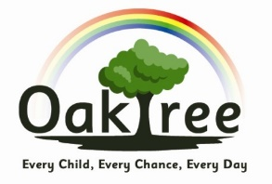
Oaktree School Council
September 2021

Present: Freya (Year 1), Henry (Year 1), Freddie (Year 2), Skye (Year 2), Alexandra (Year 3), Supreme (Year 3), Robin (Year 4), Kori (Year 5), Layla (Year 5), Tamaya (Year 6), Daisy (Year 6)
Absent: Layla (Year 4)
Welcome: Mrs Rogers welcomed all newly elected representatives to the school council.
Council roles and responsibilities: The children identified a list of what they considered to be their main roles and responsibilities:
- to help people in our school community
- to make the school an even better place
- to make positive changes to our school environment
- to raise money to support national and international charities
Goals and aspirations: Each representative had the opportunity to share something that they would like to achieve during their time as a school councillor. A few ideas were:
- making football more enjoyable and fair by introducing referees;
- developing the school allotment to grow our own fruit and vegetables for children to eat and planting more flowers around the school site to make it more colourful and friendly to the wildlife;
- showing all children how to play nicely and share equipment at play time;
- build in time to celebrate different cultures and their languages;
- providing extra games/play equipment for the KS2 playground or possibly repainting the old ones;
- arranging a variety of afterschool clubs e.g. colouring, coding and football
- sharing our work with parents and the rest of the community.
Fundraising: Mrs Rogers explained that Children in Need is in November and asked the children for possible fundraising ideas. The children agreed they would ask their class members for ideas also.
Actions: Ahead of the next meeting, all representatives agreed to feedback to their class on what we discussed. They would ask class members for their ideas about school clubs and fundraising.

