Year 6 Reading Spine
Books from our enquiries

Term 1  How are lives saved? | Term 2  Who were the greater engineers: Ancient Britons or Victorians? | Term 3  How do we all live together?
The Fastest Boy in the World – Elizabeth Laird | Wolf Brother – Michelle Paver  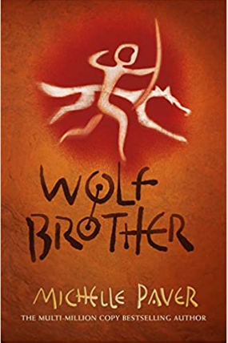 | You Rule! – Scott Forbes & Emma Laura Jones  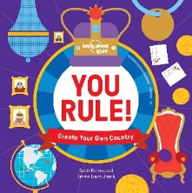  Weslandia – Paul Fleishmann 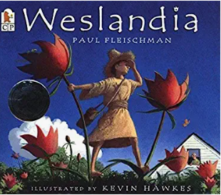
Term 4  Where does our food really come from? | Term 5  Linnaeus and Darwin: how are they connected? | Term 6  What is your footprint?  Why are shadows important?
Out of the Ashes - Michael  Morpurgo  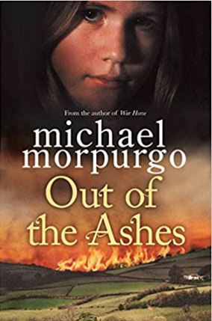 | Darwin’s Dragons – Lindsay Galvin  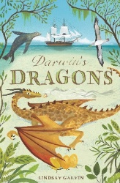  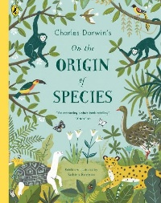  The Origin of Species – Sabina Radeva | The Arrival – Shaun Tan  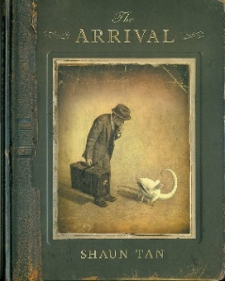

Books Recommended by current and past Year 6 pupils

Amari and the Night Brothers – B.B. Alston | Love Frankie – Jaqueline Wilson | Cloud Boy – Marcia Williams
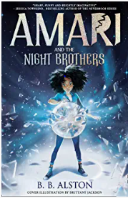 | 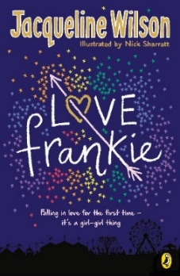 | 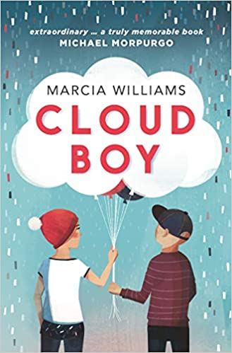
The Boy at the Back of the Class – Onjali Q. Raúf | A Kid in my Class – Rachel Rooney | The Great Dream Robbery – Greg James & Chris Smith
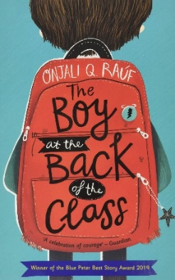 | 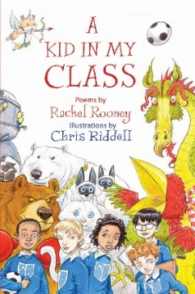 | 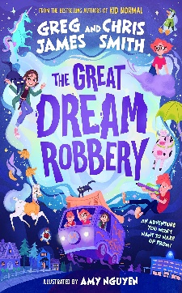
Journey to the River Sea – Eva Ibbotson | The Pants Project – Cat Clarke | Orphans of the Tide – Struan Murray
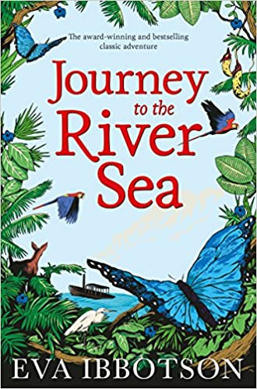 | 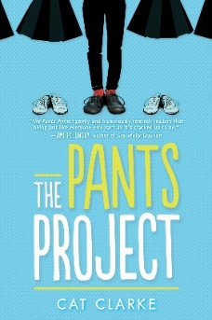 | 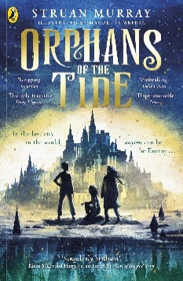
Into the Mouth of the Wolf – Michael Morpurgo | The Boy Who Hit Play – Chloe Daykin | Corey’s Rock – Sita Brahmachari
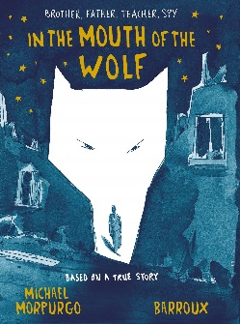 | 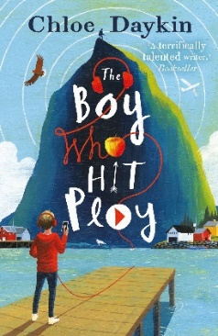 | 