**Design**

**Upper KS2**

* Develop their own design criteria based on findings from investigating existing products.
* Ensure design criteria are specific to a target user
* Draw designs from different views, including top, front and side views, cross-sectional diagrams
* Model ideas through making prototypes
* Clearly identify and name the components required for the product
* Use knowledge of forces, mechanisms and structures e.g. triangulation to create effective designs.

**Lower KS2**

* Create design criteria, considering the target audience. Follow a design brief
* Research a topic e.g. ‘The Romans’ to develop a range of initial ideas
* Generate a final design, considering which initial design best fits the criteria and audience.
* Draw labelled diagrams of their designs, including exploded diagrams.
* Draw nets to create structures from
* Design and make templates from an existing product

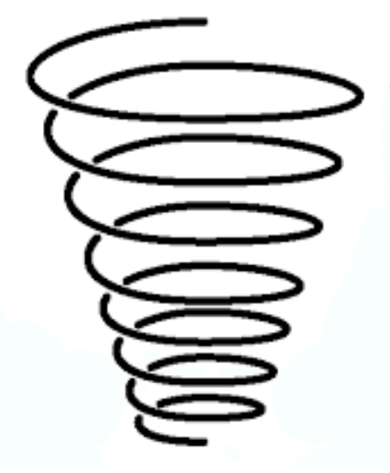

**KS1**

* Learn the importance of clear design criteria
* Create labelled drawings of designs
* Explain how to adapt mechanisms to control movement.
* Learn about structures
* Use given templates to create designs for products

EYFS

* Draw their own designs
* Make verbal plans and material choices



**KS1**

* Cut fabric neatly with scissors
* Use fabric glue to decorate
* Sew using running stitch
* Select materials according to their characteristics.
* Make linkages using split pins and card.
* Cut and assemble components using scissors.
* Make stable structures from card, tape and glue.
* Follow instructions to make a structure.

EYFS

* Explore ways to join materials using glue, paperclips and tape and yarn
* Safely use and explore a variety of materials, tools and techniques, experimenting with colour, design, texture, form and function.
* Begin to develop cutting skills (scissors, saws, knives)

**Upper KS2**

* Follow a design brief to make products with a focus on accuracy and a high-quality finish.
* Make moving mechanisms including sliders, pivots and folds.
* Re-inforce and strengthen structures.
* Independently measure, mark and cut components accurately using rulers, scissors, saws (card, wood, fabric).
* Select materials and explain why they have been selected.
* Use a range of materials to add decoration to structures.
* Make, test and incorporate components in a circuit in a design, including series circuits.
* Measure, mark and cut fabric independently.
* Userunning stitch and blanket stitch to join components and a range of decorative stitches.

**Lower KS2**

* Follow a design and use design criteria when making.
* Use a template
* Create 3D structres using a net
* Measure and mark out using rulers or templates with minimal support
* Select materials due to their functional and aesthetic properties.
* Select and use appropriate tools for cutting, joining, shaping and decorating materials (foam, fabric,
* Use cross-stitch and applique to decorate fabric.
* Sew fabric using running stitch and back stitch using even, neat stitches.
* Create frame structures and reinforce the structure.
* Create simple moving models using pneumatic systems to create a desired motion.
* Incorporate simple circuits using a switch and a components (bulb).

**Make**

**Cooking & Nutrition**

**Upper KS2**

* Cut and prepare vegetables safely
* Research and select recipes to meet given criteria
* Follow a recipe, including weighing out ingredients correctly
* Work safely and hygienically with independence, avoiding cross-contamination
* Suggest improvements to recipes
* Use equipment safely including knives, hot pans and hobs.
* Evaluate a recipe considering taste, smell, texture, budget and origin of foods.

**Lower KS2**

* Prepare a safe workspace and gather the equipment needed by a recipe
* Follow a recipe from start to finish
* Know and follow food contamination and hygiene rules
* Adapt or modify a recipe to meet new criteria or to improve the outcome.
* Evaluate a recipe, considering taste, smell, texture, appearance and budget.



**KS1**

* Learn the importance of clear design criteria
* Create labelled drawings of designs
* Explain how to adapt mechanisms to control movement.
* Learn about structures
* Use given templates to create designs for products

EYFS

* Taste a range of food and explain their preferences.
* Regularly cook a set recipe to develop proficiency
* Name some fruits and vegetables

**Technical Knowledge**



**KS1**

* To know how to stiffen and strengthen structures
* To understand axles and wheels
* To know that different materials have different properties and are suitable for different uses.
* Know there are different sewing stitches

EYFS

* To know some objects float and others sink
* To know some materials are waterproof

**Upper KS2**

* To know how mechanisms can change one type of movement into another.
* To understand the mechanisms of a variety of cams, axles, followers and pivots.
* To understand some ways to reinforce structures
* Know that properties are words that describe the form and function of materials and why material selection based on properties is important.
* Know that small, neat stitches are stronger and more secure.
* Know the use of a template for accurate marking out.

**Lower KS2**

* Understand how pneumatic systems work and can be part of a mechanism.
* To understand the affect of air-resistance on different shapes.
* To understand wide and flat-based objects are more stable.
* Know the importance of strength and stiffness in structures.
* To know how to leave space in fabric to create a seam.
* To know the uses of different fastenibg devices (zip, toggle, button, Velcro, press-stud)

**Upper KS2**

* Analyse the features of existing products, identifying strengths and weaknesses.
* Suggest points for improvements with reasons for their own and others work.
* Apply points of improvement to modify designs and products.
* Test products explaining what went well and what could be improved.
* Describe changes they would make if they were to do the project again
* Reflect on their work continually throughout the design and make process.

**Lower KS2**

* Analyse and evaluate an existing product, identifying it’s key features and comparing advantages and disadvantages of similar products.
* Evaluate their own and others work based on aesthetics, the original design and design criteria.
* Use the views of themselves and others to improve designs.
* Suggest improvements, justifying opinions.



**KS1**

* Test a product and review its success.
* Verbally evaluate designs against own design criteria.
* Use peer feedback to modify a design.
* Reflect on a finished product, explaining their likes and dislikes.
* Identify and explain why they like aspects of a peers work.

EYFS

* Explore a range of products e.g. boats, bookmarks, toys and say their likes and dislikes
* Share their own creations and explain how they made them.

**Evaluate**