Ladybirds Adult Supported Activities
Squiggle Whilst You Wiggle | Dough Gym | P.E in the hall | Woodland and Forest | Read, Write, Inc.
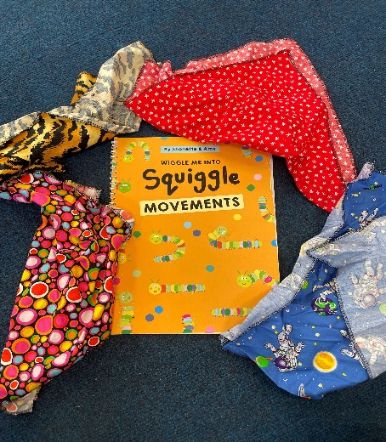 | 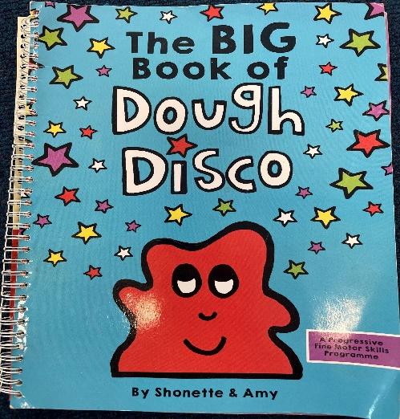 |  | 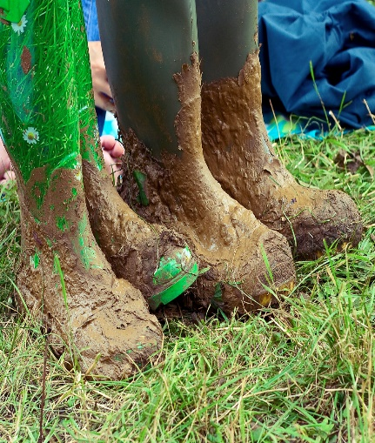 | 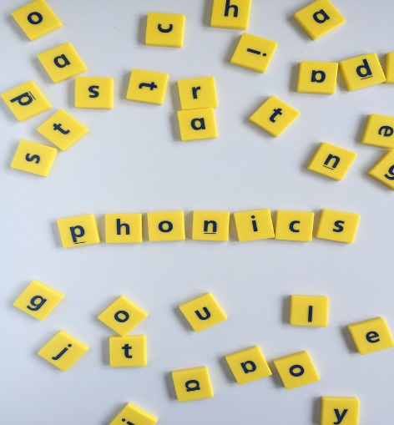
When your child first arrives for their session, the music will be playing, ready for your child to take part in our dancing activity.  We have a variety of different scarves for your child to choose from. This activity is incredibly fun, motivating and excites the children to engage in gross motor skills and writing. It’s all about mark making and how to develop children's writing in a fun and exciting and extremely active way. | After snack the children will take part in our Dough Gym activity. We sing lots of different songs, that encourage the children to manipulate the dough in many different ways.  This is a physical activity that helps to develop your child’s fine and gross motor skills. Whilst also helping your child’s hand/eye coordination, balance, dexterity and pencil control. | Ladybirds will have an allocated slot in the hall, where the children can take part in different physical activities.  Going to the hall also gives the children the experience of the school environment. | Throughout the year, we will make trips to the Woodland and into the forest area.  The Woodland and forest will give your child the opportunity to explore different environments, and to learn in different ways.  Example of activities; Pumpkin hunts and leaf rubbing.  Please can you provide your child with some welly boots. We just love to jump in muddy puddles! | Read, Write, Inc. is a phonics tool we use in Oaktree.  In Nursery this will be a very simple phonics activity, and will be done during Circle Time. Alongside this, we will read lots of different stories, and sing lots of different songs.

We will also be visiting the Foundation Stage library during the week, where your child can choose a book of their choice and bring it home to share with you.

