Year 5 Top 10 books
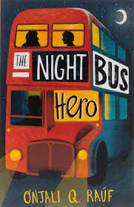
1. The Night Bus Hero by Onjali Q Rauf
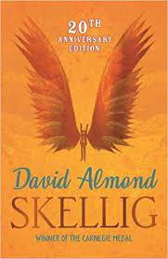
2. Skellig by David Almond
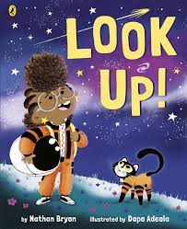
3. Look Up by Nathan Bryon
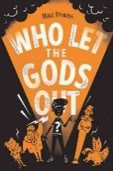
4. Who Let the Gods Out by Maz Evans
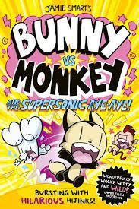
5. Bunny Vs Monkey by Jamie Smarts
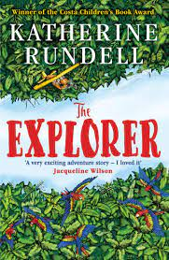
6. The Explorer by Katherine Rundell
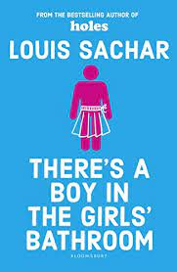
7. There’s a Boy in the Girls’ Bathroom by Louis Sachar
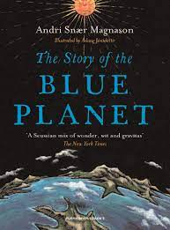
8. The Story of the Blue Planet by Andri Magnason
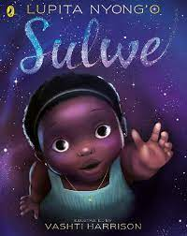
9. Sulwe by Lupita Nyong

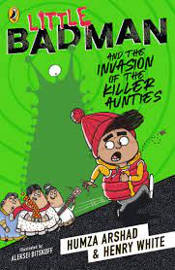
10. Little Badman and the Invasion of the Killer Aunties by Humza Arshad & Henry White

