Science progression spiral: Working Scientifically, Recording

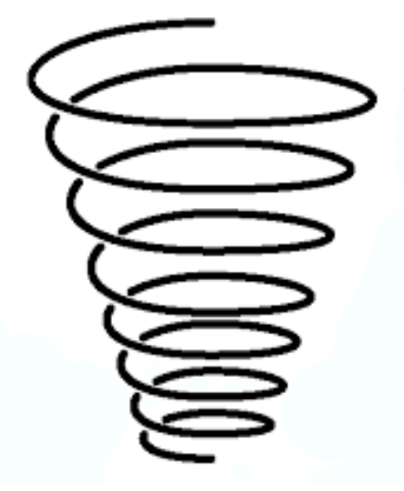

UKS2:

recording data and results of increasing complexity using scientific diagrams and labels, classification keys, tables, scatter graphs, bar and line graphs

LKS2:

gathering, recording, classifying and presenting data in a variety of ways to help in answering questions

recording findings using simple scientific language, drawings, labelled diagrams, keys, bar charts, and tables

EYFS:

Discuss what they can see in simple diagrams (e.g. groups of objects)

KS1:

gathering and recording data to help in answering questions, using pictograms, photographs and verbally