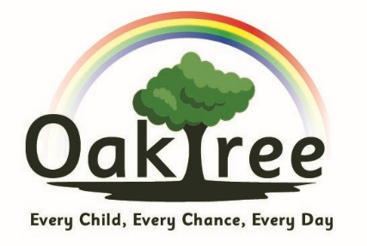
Oaktree Nursery and Primary School
Languages Policy
March 2022
Purpose of study:
“Learning a foreign language is a liberation from insularity and provides an opening to other cultures. A high-quality languages education should foster pupils’ curiosity and deepen their understanding of the world.
The teaching should enable pupils to express their ideas and thoughts in another language and to understand and respond to its speakers, both in speech and in writing. It should also provide opportunities for them to communicate for practical purposes, learn new ways of thinking and read great literature in the original language.
Language teaching should provide the foundation for learning further languages, equipping pupils to study and work in other countries.”
The National Curriculum in England: Key stages 1 and 2 Framework. September 2013

Context:
Oaktree Nursery and Primary School is a two-form entry school with approximately 380 pupils. For the majority of our pupils, their first language is English, although around 25% of our children have English as an Additional Language (EAL). The Key Stage Two (KS2) classes have been language learners with Primary Languages Network since September 2020, with a view to introducing it in KS1 in the near future.

Vision:
At Oaktree, we believe that the learning of a language provides a valuable educational, social and cultural experience for our pupils. It helps them to develop communication skills, including key skills in speaking, listening, reading and writing. The children’s knowledge of how language works will be developed and extended. Lessons will enable pupils to make substantial progress in one language. The linguistic skills gained will assist and lay foundations for further language learning. It will provide pupils with the confidence and independence to explore and be able to attempt manipulation of the structure of language. Learning another language gives children a new and broader perspective on the world, encouraging them to understand their own cultures and those of others.

Organisation:
Children in KS2 learn Spanish, and are taught by the class teacher or teaching assistant directly for 20 / 30 minutes per week and we aim to follow up activities when appropriate outside of the language lesson. One year group will attend the local secondary school for direct teaching from a language teacher.

Management and Training:
The subject is managed by the Languages Coordinator. To ensure the language skills of our staff are developed and sustained, Oaktree is a member of the Primary Languages Network. This provides all the materials, resources and support, sound files and activities to enable us to ensure progression in language learning across the four core skills and also the DfE 12 Attainment Targets. The Coordinator will advise, work with and guide staff where needed.

Our Curriculum:
We follow the Primary Languages Network. It is a live scheme which is continually updated and revised in order to meet with current curriculum standards. Alongside the planning provided, the network also enriches this through accompanying power points, podcasts (spoken by native speakers), links to authentic literature, songs, games, culture points of reference and links to appropriate websites.

Teaching and Learning:
To promote an active learning of languages, a range of teaching methods are implemented to ensure that the children are developing their linguistic skills through listening, speaking, reading and writing in order to be secondary-ready. Activities can consist of actions, rhymes, stories, song, drama, grammar focus, video clips, air-writing, sentence structure, dictionary work, book making and many more creative ways to extend, embed and combine language skills.

Assessment:
Currently, assessment is informal across the four language skills throughout KS2.

Monitoring:
The Languages Coordinator discusses language learning with the class teachers, where necessary, and monitors spoken and written evidence of progress in learning. The school is working toward effective progress across the four years of KS2. All teachers and learning support assistants (where applicable) can access training in monitoring via the PLN platform, consultation time, and email discussion.

Continuing Professional Development:
The Languages Coordinator attends PLN Coordinators’ CPD and the annual PLN Conference. The Languages Coordinator is a member of the network email group and can access the PLN Twitter account, the PLN website (https://primarylanguages.network/), network blog sites and the PLN blog to obtain current and up-to-date information. All staff have access to the PLN platform and, most importantly, all its CPD materials.

