Music progression spiral: Listen and Appraise

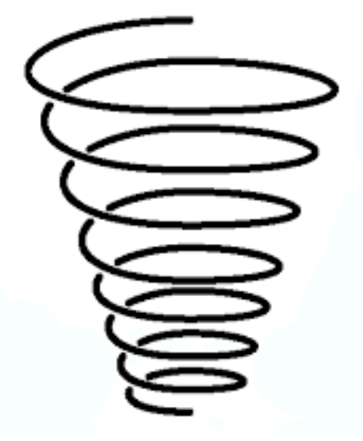

UKS2:

* To think about the message of songs.
* To compare two songs in the same style, talking about what stands out musically in each of them, their similarities and differences.
* Listen carefully and respectfully to other people’s thoughts about the music.
* To talk about the musical dimensions working together in the Unit songs – pitch, pulse, rhythm, tempo, dynamics, timbre, texture
* Talk about the music and how it makes you feel, using musical language to describe the music

LKS2:

* To confidently identify and move to the pulse.
* To think about what the words of a song mean.
* To take it in turn to discuss how the song makes them feel.
* Listen carefully and respectfully to other people’s thoughts about the music.
* to understand how different musical elements are combined and used to create an effect – pitch, pulse, rhythm, tempo, dynamics

EYFS:

* To learn that music can touch your feelings.
* To enjoy moving to music by dancing, marching, being animals etc.

KS1:

* To learn how they can enjoy moving to music by dancing, marching, being animals or pop stars.
* To learn how songs can tell a story or describe an idea.
* To begin to understand that musical elements can be used to create different moods and effects – pitch, pulse