A TYPICAL SESSION IN NURSERY
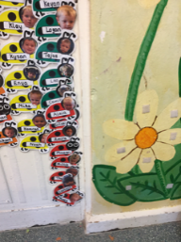
SESSIONS RUN FROM 8.45am – 11.45am OR 12.15pm – 3.15pm
The children arrive and collect their ladybird name card from the wall and put it on the tree.

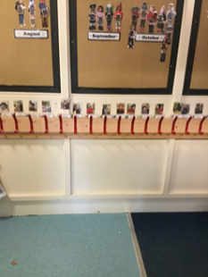
The children will then hang their own coats and bags up on their pegs

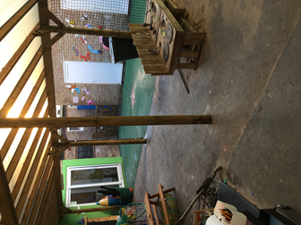
We then have Free- play where children can choose when and how to play. The outside area will be open in all weathers and the children can choose to play outside

After an hour and a half of free-play, the children will be encouraged to tidy up and look after their Nursery.
The Nursery Teacher then holds a circle time, starting with our hello song. This time will be adult led and include initial phonics activities or math
It will then be snack time. The children will be offered a choice of milk or water and a carbohydrate based snack e.g. crackers, rice cake, cereal. The children will have a choice of fruit
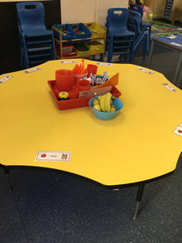
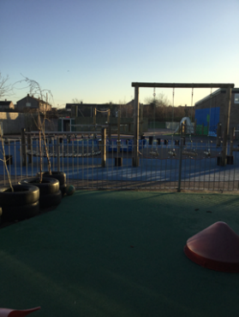
After snack time, the children will brush their teeth
It is nearly home time. The children spend the last twenty minutes playing on the large equipment in the outside playground

We finish with a story and our goodbye song

