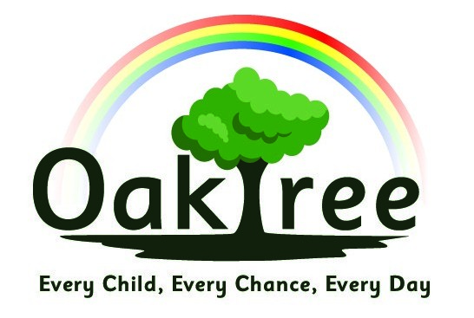
Oaktree Nursery and Primary School
Geography Policy

Rationale and Intent:
At Oaktree Nursery and Primary School we believe that all children should receive a rich and varied curriculum, which helps them to makes sense of the world around them and gives them the knowledge and skills to reach their full potential. We believe learning should be fun and motivating, and that children learn best when they are excited and eager to engage in their learning.
Through Geography, it is our intent for children to:
- be excited and curious about the world around them
- have a secure understanding that the world is made up of human and physical features
- be able to question, compare and explain the differences between different locations & cultures
- communicate clearly and coherently their findings in a variety of ways
- understand how people can shape the world, including the impact they can have

Policy into practice:
- Geography knowledge and skills are taught through ‘enquiries’, which are cross curricular and are part of our Curious City approach to learning.
- Progression is shown through depth of understanding and application of knowledge, from observing and recognising in key stage one, comparing and describing in lower key stage two, to explaining and suggesting reasons in upper key stage two
- Early Years Foundation Stage will follow the EYFS areas of learning and develop early geographical skills through understanding the world
- All children will be given opportunities to study geography, with work being differentiated when required to ensure access for all students
- All children will engage in fieldwork within our local area, or within our school grounds
- All year groups will be encouraged to use our school grounds to provide outdoor learning opportunities

Recording and monitoring:
- Children will present their knowledge and understanding in a variety of ways in all year groups
- Teachers will oversee work completed to ensure accurate understanding, and deal with misconceptions as they arise.
- Teachers will provide feedback to children either verbally, or through a mark or comment on their work
- Any gaps in learning will be addressed by class teachers
- the geography coordinator will moderate geography at least annually, including planning, work and a pupil voice

Covid guidance
- During Coronavirus, all fieldwork will take place within the school grounds.
- All resources used are to be quarantined for 3 days before being used by a different bubble

Date agreed: March 2021
Date of review: September 2022

