Science progression spiral: Working Scientifically, concluding

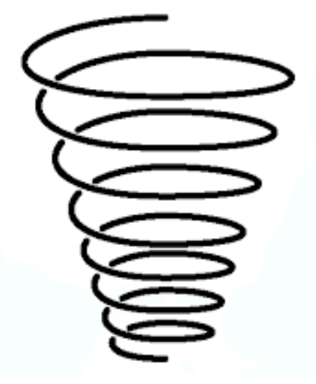

KS1:

Use their observations and ideas to suggest answers to questions

LKS2:

Report on findings from enquiries, including oral and written explanations, displays or presentations of results and conclusions

Identify differences, similarities or changes related to simple scientific ideas and processes

Use straightforward scientific evidence to answer questions or to support their findings

UKS2:

Report and present findings from enquiries, including conclusions, causal relationships and explanations of and degree of trust in results, in oral and written forms such as displays and other presentations.

EYFS:

Answer simple questions about the world around them.