**In RE we are learning about Christianity**

We will be about what it means to be a Christian and why Christians believe God gave Jesus to the World. We will be looking at the Christmas story.

**In PSHE - Celebrating Differences**

We will be identifying ways in which we are different and similar. We will be celebrating our differences and learning about respect for each other.

**In Art we are focussing on drawing**

We will use drawing, collage and sketchbooks to know:

**That drawing is a physical and emotional activity. That when we draw, we can move our whole body.**

**That we can control the lines we make by being aware of how we hold a drawing tool, how much pressure we apply, and how fast or slow we move.**

**That we can draw from observation or imagination.**

**That we can use colour to help our drawings engage others.**

**In PE we are:**

This term we are focusing on ‘Multi-skills’ which develops their skills in throwing and catching.

We will learn skills to enable us to catch a ball safely.

We will learn different ways of passing a ball to teammates

(chest pass, overhead pass, underarm throw).

We will be building our coordination skills and enhancing our balance skills when moving or being still.

Our continuing skill will be learning how to be part of a team and working together.

**In English we are learning:**

**Writing**

To write non-fiction sentences with sentence stems for support.

To understand the features of an information text

To use a range of suffixes in our writing.

To use ‘and’, ‘but’ and ‘because in our writing.

To use contractions correctly.

To develop our writing using more complex sentences and vocabulary

To improve the standard of our handwriting.

**Reading**

To continue to improve our reading skills in phonics lessons using matched texts.

To practise reading more complex texts

To improve our comprehension using skills we are learning when listening to texts.

**Phonics**

To continue to learn and practise new sounds.

To use our phonics in our reading and writing.

**Oracy**

To speak our ideas in full sentences before we write them, using the sentence stems provided.

**In computing we are learning about digital photography.**

We will learn to recognise that different devices can be used to capture photographs and will gain experience capturing, editing, and improving photos. Finally, they will use this knowledge to recognise that images they see may not be real.

**States of Being:**

**We are being Geographers**

We will identify attractive and unattractive features of the environment

We will identify physical and human features through pictures We will use aerial photos of the local area to identify where features in our local environment are.

**We are being Scientists:**

We will explore and compare the differences between living, dead and things that have never been alive.

We will identify that most living things live in habitats to which they are suited and describe how different habitats provide for the basic needs of different kinds of animals and plants, and how they depend on each other

We will identify and name a variety of plants and animals in their habitats, including micro-habitats

We will describe how animals obtain their food from plants and other animals, using the idea of a simple food chain, and identify and name different sources of food.

**Year 2 Term 2**

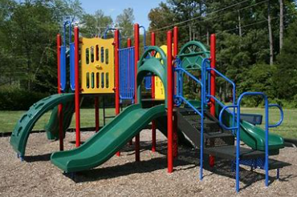

**Where do I play?**