Science progression spiral: Working Scientifically, evaluating

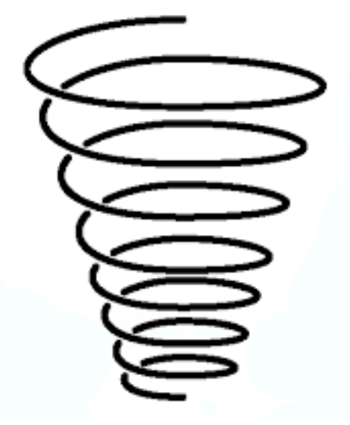

LKS2:

Use results to draw simple conclusions, make predictions for new values, suggest improvements and raise further questions.

KS1:

Be able to talk about how something was completed and give their own opinions on this.

UKS2:

Use test results to make predictions to set up further comparative and fair tests.

Identify scientific evidence that has been used to support or refute ideas or arguments

EYFS:

Give opinions with reasons for these opinions.