Oaktree Nursery and Primary School
Design and Technology Policy

Introduction

The National Curriculum states that

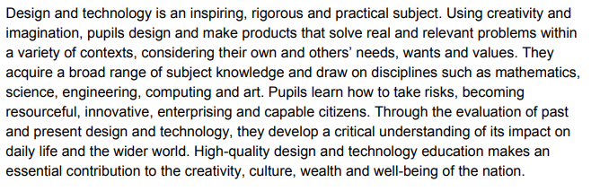
In order to ensure a wide range of projects and products, each year the children will undertake a construction project, a textiles project and learn to cook something. Children will also learn about nutrition and the origins of their food. This may be covered in science and PSHE rather than in the D&T lesson itself.

Intent: For children to

- Have the confidence and skills to solve real problems in and out of school.
- Be enterprising, resourceful and capable citizens
- Have a sense of pride in what they have achieved
- Appreciate and discuss the work of others
- Know about other sources and information to solve new and unfamiliar problems

Aims

Our approach to D&T is based upon our general school aims. As teachers we aim to:
- Provide a range of structured and differentiated activities which develop breadth and progression. Where possible these will relate to the interest and everyday experiences of our children.
- Develop knowledge and teach skills in order to design, make and evaluate products successfully.
- Help children become aware of, and investigate, simple products by disassembly and evaluation.
- Provide adequate time, access to information, skills and resources to make a good quality product.
- Motivate pupils by providing interesting and stimulating experiences.
- Provide opportunities for achievement, at all levels, standards and capabilities.
- Enable children to use design and technology to solve a range of problems.
- Each year the children will learn to cook a simple, healthy dish that they can make themselves at home.

Curriculum Organisation

Class teachers will be responsible for the delivery of D&T which will usually be part of a larger enquiry. D&T can be delivered during set D&T lessons each week or blocked within a term. The children will have the opportunity to work individually, in small groups and as a whole class in their classrooms.

The co-ordinator will facilitate the development of D&T across the Key Stages and should be viewed as a ‘resource’ to non-specialists, in promoting enrichment of the curriculum and in providing motivation and inspiration to others. Whole school planning for D&T will be undertaken by all staff.

Whole School Policy

The D&T curriculum has been developed to ensure it is an integral part of the "whole school" approach to children's learning. At Oaktree Nursery and Primary School we believe that our pupils deserve a broad and rich curriculum, and D&T is used to enrich that curriculum further. Products must be designed with a specific person or group in mind. This does not have to be a real person that we know but could be a historical figure or a fictional character if it helps to inspire and motivate the children.

Assessment, Monitoring and Evaluating

Class teachers will be responsible for the assessment and recording of pupil’s D&T capabilities and achievements. These achievements must be praised and rewarded as would any exceptional achievements in other subjects.

This policy will be reviewed bi-annually. Development of teacher’s expertise may be provided through in-school inset provision, in class support from the co-ordinator, focused staff meetings and attendance of externally held courses.

Role of the Co-ordinator

The co-ordinator works with the whole staff to develop a cohesive D&T experience throughout the school. The co-ordinator will also:

- support colleagues in their planning of D&T if needed.
- take responsibility for the purchase and organisation of resources for D&T
- monitor delivery throughout the school.

Equal Opportunities

It is our intention to provide each and every pupil with a broad and balanced D&T curriculum. A curriculum which also approaches those key issues associated with multi-culture and gender. It is our belief that all children (regardless of their own particular ethnic group) have the same entitlement to a broad and varied multi-cultural D&T education, an education which provides a unique insight into the historical and contemporary traditions of both their own culture and that of other nationalities. In addition, every effort is made to seek out ways of reinforcing sexual equality within the classroom where both sexes are treated fairly and are provided with the same educational opportunities. Children with SENs should be able to access the full D&T curriculum and teachers must ensure this happens. Any concerns about adapting tasks can be discussed with the co-ordinator or SENCo.

Health and Safety

In teaching certain practical elements of D&T to pupils, we recognise that safety is a key issue. All safety precautions must be taken. This is done by recognising health and safety in the classroom organisation and, furthermore, by giving children guidance on how to use the equipment provided. Monitoring the pupils in small groups helps overcome the problems of safety when using potentially dangerous D&T equipment. Children will be introduced to the correct techniques for handling D&T equipment and will develop these techniques as they progress through the school. The co-ordinator is always available to guide staff in the safest ways of using various equipment. Children are encouraged to risk assess each task as they approach it and teachers should ensure that they talk this through with the children before starting practical tasks.

Date Reviewed: March 2021
Date to be reviewed: September 2023

Date approved by Governors:
Signature of Chair of Governors:

