Science progression spiral: Working Scientifically, observing

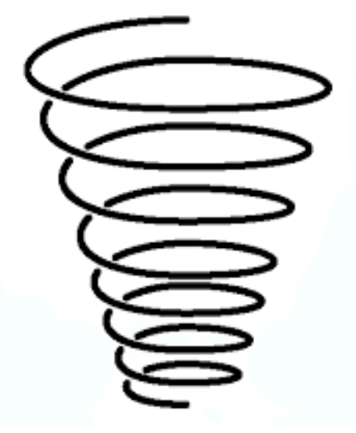

LKS2:

Make systematic and careful observations and where appropriate, take accurate measurements using standard units, using a range of equipment, including thermometers and data loggers

EYFS:

Group items according to their own criteria.

KS1:

Observe closely, using simple equipment. Perform simple tests. Identify and classify objects.

UKS2:

Take measurements, using a range of scientific equipment, with increasing accuracy and precision, taking repeat readings where appropriate