Phonics groups and what they mean

Group | I can… | My target is to…
Set 1A 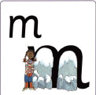 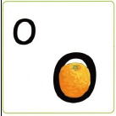 | Recognise some single letter sounds | Recognise all single letter sounds.  Orally blend sounds
Set 1B | Recognise most or all single letter sounds | Orally blend sounds  Blend sounds to read short words e.g. cat, box, tin
Set 1C m-a-t | Recognise most or all single letter sounds. I can blend sounds into words orally. | Blend sounds to read short words e.g. cat, box, tin
Ditties 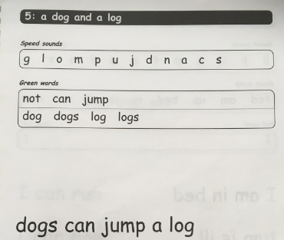 | Read 2 or 3 sound words independently (am, red, bin) | Recognise the Set 1 digraphs (‘Special Friends’) and read them in words  sh ch qu ng nk th
Red books 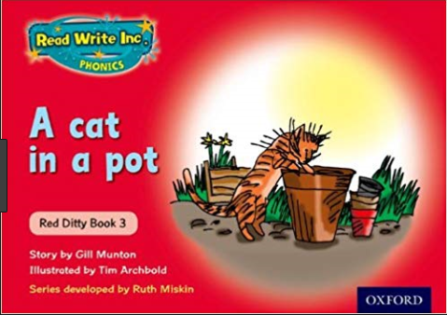 | Recognise the Set 1 digraphs (‘Special Friends’) and read them in words | Read words with 4 and 5 single letter sounds  stop jump stamp crept  Read words with 3 sounds speedily  man got sit
Green books 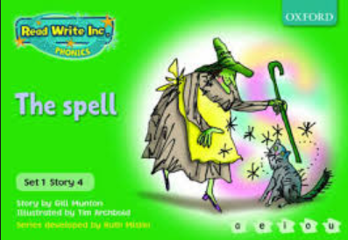 | Read words with 4 and 5 single letter sounds | Teach additional sounds:  ll, ss, ff, ck  Read the first 6 Set 2 sounds and in words  ay ee igh ow oo oo  Read words with 3 sounds that contain a digraph speedily  this chip quiz
Purple books 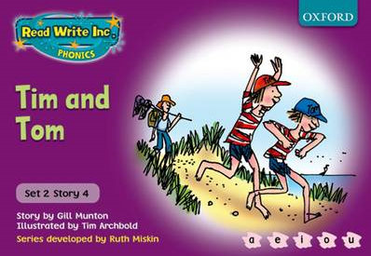 | Read words with 4 and 5 single letter sounds | Read the first 6 Set 2 sounds and in words, including multisyllabic  ay ee igh ow oo oo  Read words with 4 and 5 sounds speedily  stop jump stamp crept
Pink books 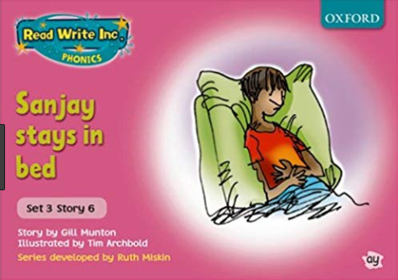 | Read the first 6 Set 2 sounds and in words, including multisyllabic  ay ee igh ow oo oo  Read words with 4 and 5 sounds speedily  stop jump stamp crept | Read the next 6 Set 2 sounds and in words, including multisyllabic  ar or air ir ou oy  Read words with the first 6 Set 2 sounds speedily  play night sleep about
Orange books 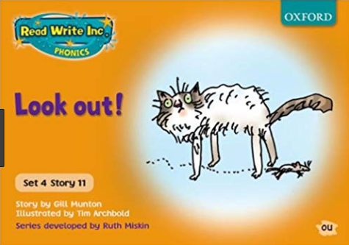 | Read the next 6 Set 2 sounds and in words, including multisyllabic  ar or air ir ou oy  Read word with the first 6 Set 2 sounds speedily  play night sleep about | Consolidate Set 2 sounds  Read the first six Set 3 sounds and in words, including multisyllabic  ea oi a-e i-e o-e u-e
Yellow books 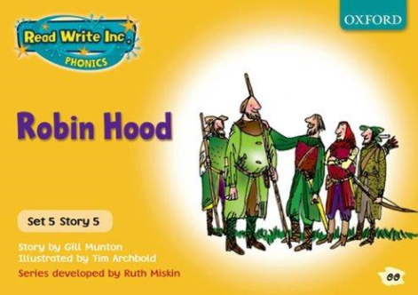 | Read the first six Set 3 sounds and in words, including multisyllabic  ea oi a-e i-e o-e u-e | Continue reading Set 3 sounds and in words, including multisyllabic  aw are ur er ow ai  oa ew ire ear ure  Build speed for reading whole texts (60-70 words per minute)
Blue books 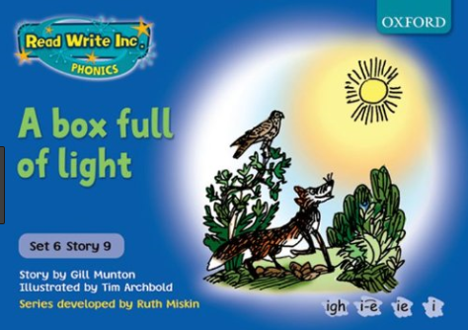 | Read learnt Set 3 sounds and in words, including multisyllabic  Can read whole texts at 60-70words per minute | Continue reading Set 3 sounds and in words, including multisyllabic with growing speed  au e-e ue ie ph wh kn  Build speed for reading whole texts (70-80 words per minute)
Grey books 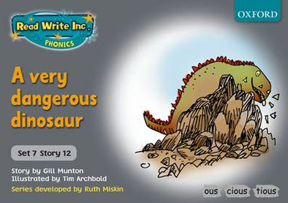 | Can read Set 3 sounds and in words, including multisyllabic with growing speed  Can read whole texts at 70-80 words per minute | Continue reading Set 3 sounds and in words, including multisyllabic with speed  Read words ending in  tion tious cious  Build speed for reading whole texts (90-100+ words per m)

